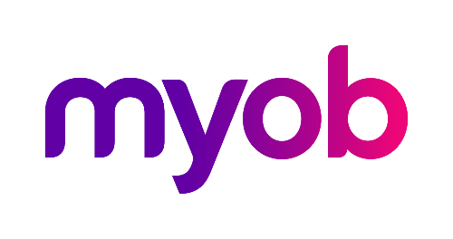
MYOB Greentree
Release Notes
2017.2.0

Contents
Overview 1
New features – Greentree desktop 2
Windows Designer 2
Payroll Day Summary Report 9
Greentree Package Manager Optimisation 10
Upgrade to JADE Version 7.1.09 11
Enhancements - Greentree Desktop 12
Attachments on Physical Asset Maintenance Cycles 12
Greentree Provides More Information about Locked Objects 12
Enhancements - Greentree Browser 13
Enter Negative Hours in Browser Timesheets 13
Finish Time on Timesheets Can Be After Midnight 14
Bug Fixes - Greentree Desktop 15
Bug Fixes: Greentree Browser 16

Overview
Greentree release 2017.2.0 contains several new features and enhancements in both MYOB Greentree Desktop and Greentree Browser.
In Greentree Desktop, we've added a tool for customising forms and a new payroll report. We've also optimised the Greentree Package Manager (Packman) utility and have upgraded the version of JADE used with Greentree to 7.1.09.
In Greentree Browser, we've added the ability to enter negative hours in timesheets and for employees to enter finish times that cross midnight into their timesheets.

New features – Greentree desktop
We've added the following features to Greentree Desktop:

Windows Designer
Windows Designer enables you to make modifications (called customisations) to Greentree Desktop forms, including:
- Changing the text on field or button labels.
- Moving fields, buttons, and checklists around the form.
- Hiding fields and buttons that users shouldn't have access to or aren't interested in seeing.
- Adjusting the width of fields.
- Formatting controls on a form to make them stand out.
- Changing the order of tabs on a form.
You can also create multiple customisations of a form. You might, for example, want to create a customisation that hides those fields from certain users, while having another customisation of the same form for teams that require those hidden fields but which also need a search results table to be read only.
There are a number of items that you can't modify, including:
- Module Control forms.
- Certain workflow forms.
- Calculations in fields.
- Table columns.
- The layout of the account ledger.
- Icons on a form's toolbar.

Elements of Windows Designer
Windows Designer is made up of two parts: the Windows Designer Administration form and the Editor palette.
The Windows Designer Administration form is the main point of entry into Windows Designer. It's made up of two tabs:
- The Forms tab, which contains information about the form you're customising — for example, the name and a description of the customisation, what appears on the form's title bar, who created the customisation, and who it's assigned to. You can make the customised form available to companies, teams, and users in your organisation on this tab.
- The Assignments tab, which replaces the Screen forms tab on the Greentree Desktop User Preferences form. Use this tab to manage permissions for all of Greentree forms — whether default or customised — that a company, user, or team has permissions to use.
Learn more about the Windows Designer Administration Form.
The Editor palette enables you to modify the controls on a form that you're customising. While you can't change how the controls on a form work with Greentree Desktop, you can make cosmetic changes to those controls.
Learn more about the Editor palette.
Let's look at how to customise a Greentree Desktop form using Windows Designer.

Creating a Customisation
You create a customisation by making a copy of a Greentree form and then modifying that copy.
To create a copy of a form:
- Select System > Customisation > Designer. The Windows Designer Administration form displays.
- 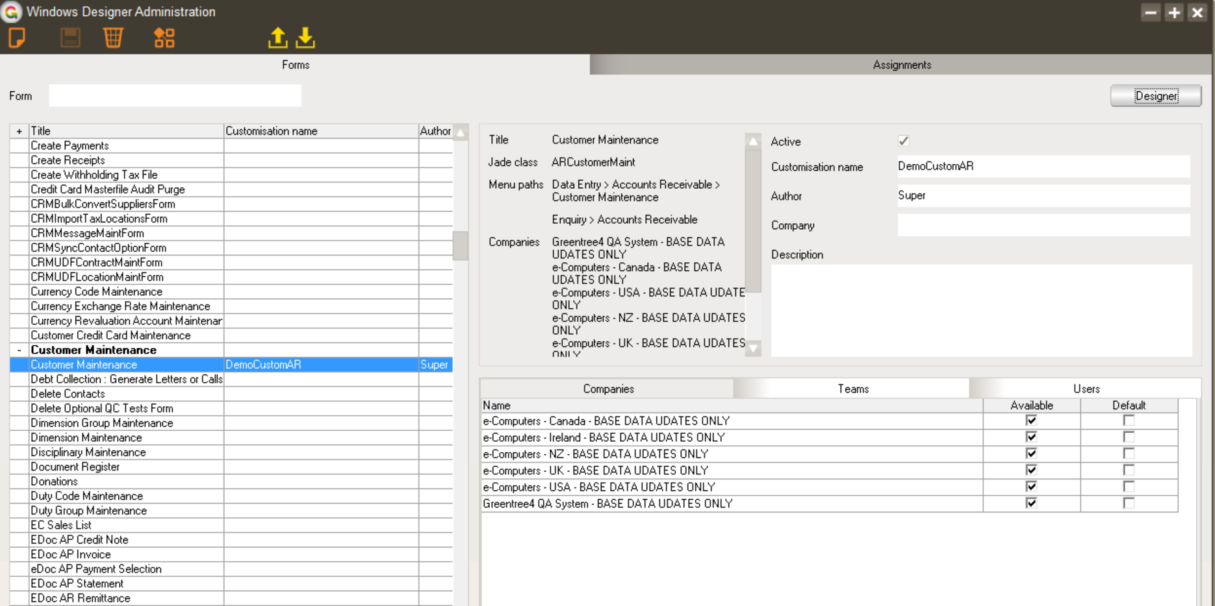
- In the left pane, select the form that you want to customise from the list.
- You can also enter all or part of the name of the form you want to customise in the Form field to search for it.

- In the right pane, do the following:
  - Enter a descriptive name for the copy of the form in the Customisation name field. This identifies the customisation in Greentree Desktop. It does not change the name that appears on the form's title bar.
  - Optionally, enter the name of the Company that the customisation is associated with. You can also enter the name of the company in the Form field to search for all of the company's custom forms.
  - Optionally, enter a detailed Description of the customisation.
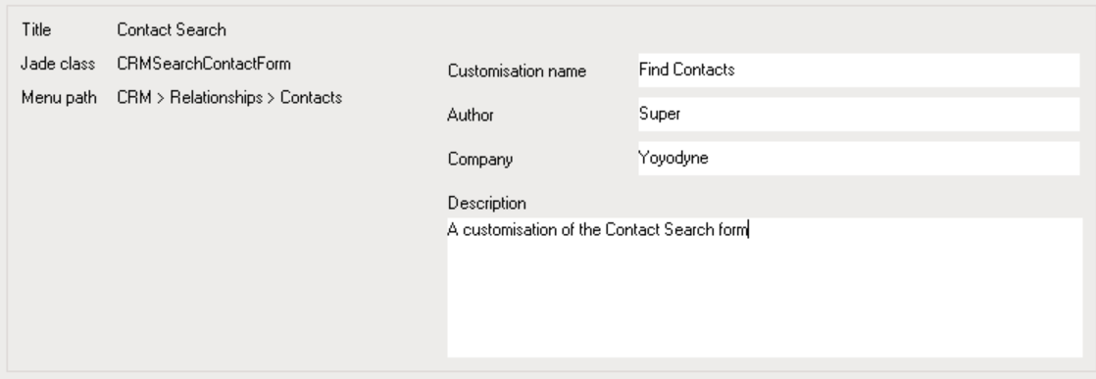
- Click the Save icon on the toolbar.
Now that you have a copy of the form, you can edit it.

Editing the Customisation
To edit a customisation, click the Designer button. This opens both a working copy of the form and the Editor palette:
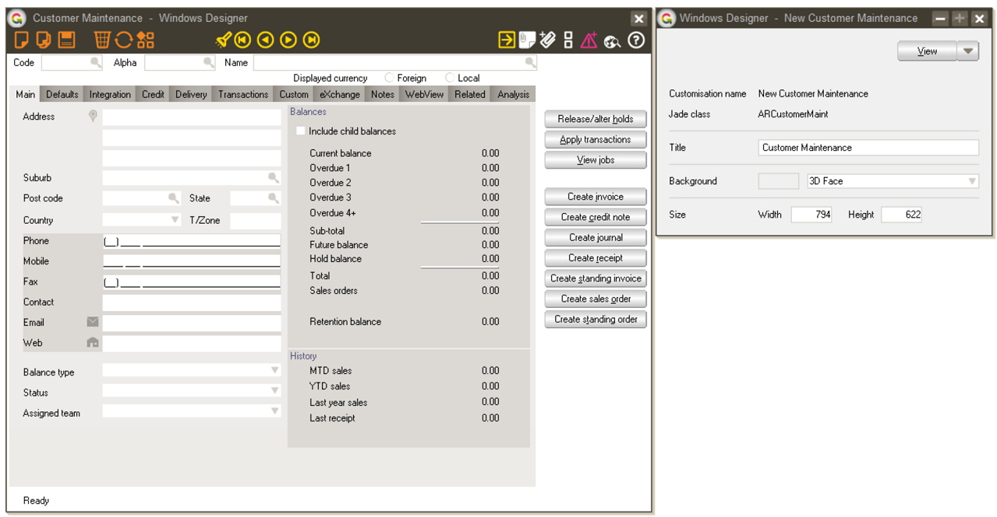
Click the control on the form that you want to edit. The Editor palette displays the information that you can change, for example:
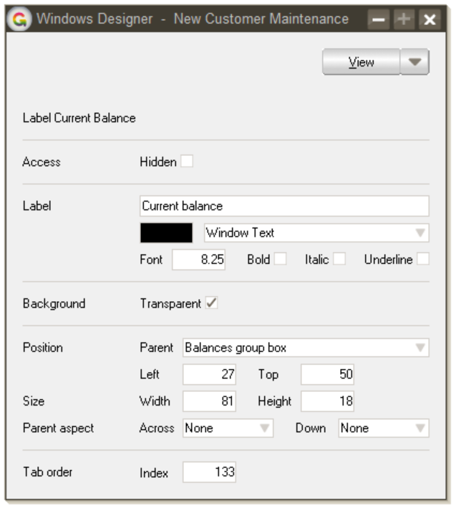
Depending on the control, you can change its size, its position on the form, the size and formatting of fonts, and whether the control is visible to the user or is read only.
You can move a control by dragging and dropping it with your mouse, or by using the arrow keys on your keyboard.
So how does all that work? Let's walk through a simple example.

Example: Customising the Contact Search Form
Let's change the title of the Contact Search form along with the following field labels:
- Email starts
- Only Contacts with email
- Show Inactive
Here's what the stock Contact Search form looks like:
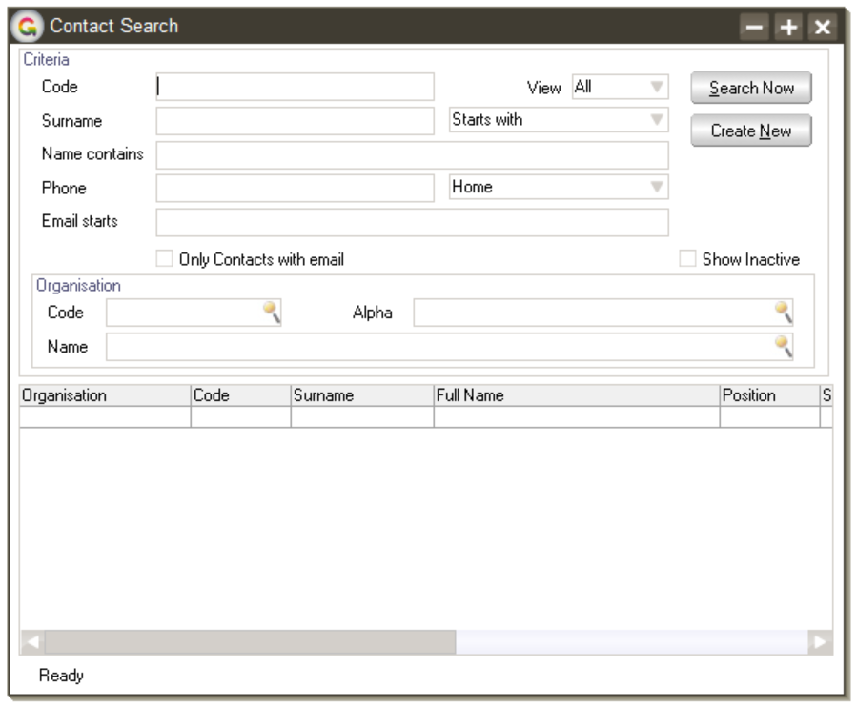
To make the changes:
- On the Windows Designer Administration form, make a copy of the Contact Search form.
- Enter Find Contacts in the Customisation name field.
- Save the customisation.
- Click the Designer button to edit the copy of the form.
- On the Editor palette, type Find Contacts in the Title field.
- Click the Email starts label and do the following in the Editor palette:
- Type Email Starts With in the Label field.
- Change the width of the label to 83 pixels in the Size area.
- Click the Only Contacts with email label and do the following in the Editor palette:
- Type Only Contacts with Email Addresses in the Label field.
- Change the width of the label to 187 pixels in the Size area.
- Click the Show Inactive label and do the following in the Editor palette:
- Type Show Inactive Contacts in the Label field.
- Change the width of the label to 131 pixels in the Size area.
- You'll notice that the new field labels overlap the fields themselves. You'll need to move those labels and fields, along with any controls adjacent to them, to the right.
- Using your mouse, you can click and drag the controls that you need to move. Or, you can select a control and move it by pressing the arrow keys on your keyboard. Using the arrow keys lets you place controls with a little more accuracy.
- Click Save.

Here's the form we just customised:
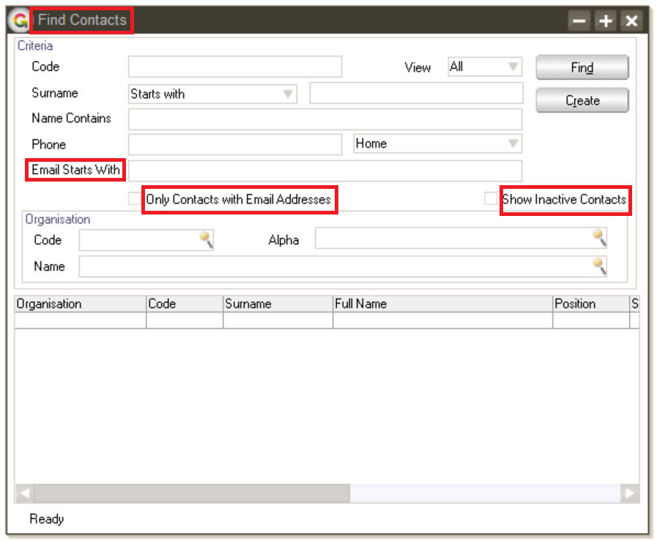

Making the Customisation Available
You have a customisation. Now what? You'll want to make it available to companies, teams, or individual users in your organisation. You do that on the Forms tab of the Windows Designer Administration form.
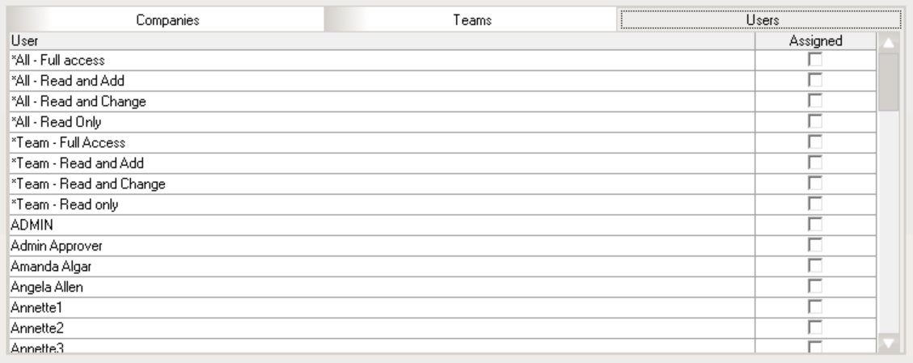

To make the customisation available:
- On the Windows Designer Administration form, select the customisation that you want to make available.
- On the Companies tab, select one or both of the following options for each company in your organisation that will use the customised form:
  - Available - The company can use the form. You'll need to assign the form to teams and users associated with the company.
  - Default - The company uses the customised form instead of the original. The customisation is available to all teams and users who have access to the original Greentree form. When you deselect this option, the original form goes back to being the default.
- Do one or both of the following:
  - Click the Teams tab and select one or more teams to which you want to assign the form.
  - Click the Users tab and select the users or groups of users to whom you want to the form.
- You’ll only see the users and teams whose menu security settings give them access to the form.
- Click the Save button on the toolbar.

Managing Form Assignments
The Assignments tab on the Windows Designer Administration form enables you to view and manage permissions for all of the forms — whether default or customised — that a company, user, or team has permissions to use. Using the Assignments tab, you can manage access to forms in one location. You don't need to log into each company a user or team works across to manage their access to forms.
To manage permissions, select one of the following options on the Assignments tab:
- Team - The team within your organisation whose access to forms you want to manage.
- User - The user whose access to forms you want to manage.
- Company - The company in your organisation whose access to forms you want to manage.
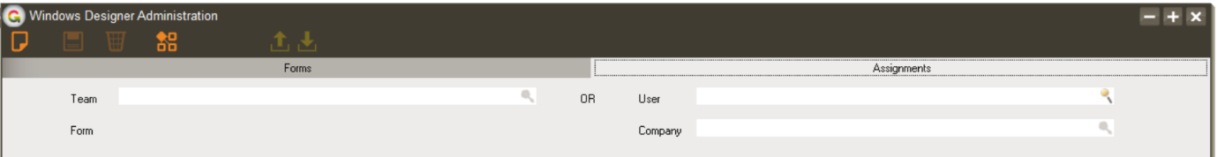

- When you’ve selected a team, company or user, you can search for the form whose access you want to manage by typing all or part of its name in the Form field.

A list of all forms in Greentree displays in a table at the bottom of the form. Customisations are highlighted in yellow. For example:

Select or deselect the option to grant or remove access to a form, then click the Save icon on the toolbar.
- The names of some forms will not have checkboxes beside them. This indicates that the user or team does not have permissions to view those forms. For example:

Exporting and Importing Customisations
You can save customisations as a Greentree Designer file (with the extension .gtwd). You can, for example, export a customisation from one instance of Greentree and import it into another. This eliminates the need to manually recreate the customisation across all of your instances of Greentree.
To export a customisation, click the Export icon () on the toolbar. You'll be asked for a file name and to choose a folder on your computer in which to save the file. Click Save.
To import a customisation, click the Import icon () on the toolbar. Find the Greentree Designer file that you want to import and then click Open.

Payroll Day Summary Report
This report is a summary of the average number of hours employees worked per day over a specified period. This report contains the same information that appears in the Day Summary section of the Balance Enquiry form.
You can set the following options to refine the information that appears in the report:
- Pay group – Select the pay group for which you want to generate the report. If you don't select a pay group, Greentree generates a report for all pay groups.
- Employee type – Select the type of employee (for example, Casual) for which you want to generate the report. If you don't select an employee type, Greentree generates a report for all employees.
- Check for work on same day of week in last weeks – Specify the number of weeks over which Greentree checks employee records for work on the same day of the week. The default is 4 and the maximum is 6.
- Hide employees who did not work all days – Select this option to only include employees who worked all days during the period the report covers.
- Hide employees who did not work any days – Select this option to only include employees who worked some or all days during the period the report covers.
Here's an example of the Day Summary report:
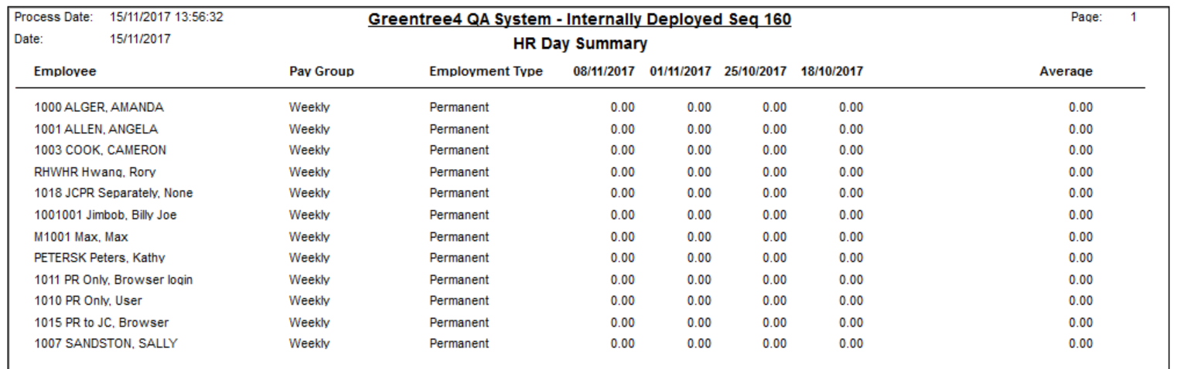

Greentree Package Manager Optimisation
Version 4.70 of Greentree Package Manager (Packman) includes the option to optimise the package import process. Optimisation is enabled by default, and improves Packman's performance.
Packman now assesses the packs to be imported and loads them in logical groups to reduce the number of entry and exit points. This reduces the number of times Packman restarts, resulting in a significant reduction in overhead.
You can change the optimisation settings in Packman's Advanced settings window.
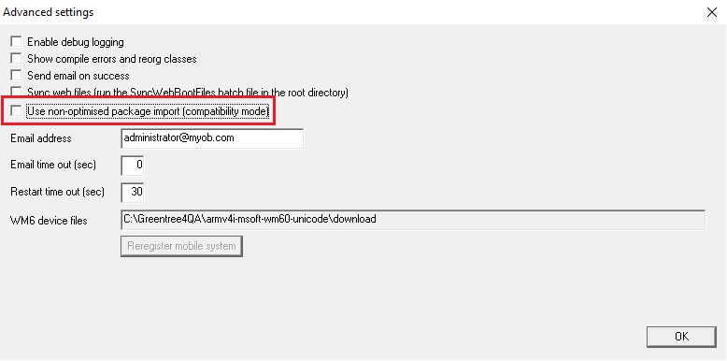
If you select the Use non-optimised package import (compatibility) option, Packman uses the old method of importing packs one at a time with an entry and exit for each pack. We've provided this option for backward compatibility if there is an unforeseen issue during the package optimisation process.

Upgrade to JADE Version 7.1.09
This release of MYOB Greentree uses JADE version 7.1.09. Version 7.1.09 of JADE supports Windows Server 2016 (while continuing to support Windows Server 2012 R2, 2012, and 2008 R2). It also supports versions 7, 8.0, 8.1, and 10 of the Windows operating system.
Greentree's Mobility solution works with JADE 7.1.09 on both newer and older scanning devices. That means even if you're using older scanners with Greentree Mobility, they'll work with the current version of Greentree. If you need to, you can purchase newer scanners (running more up-to-date versions of the Windows mobile operating system) and they'll work seamlessly with Greentree.
Here's a list of versions of the Windows Mobile operating system that JADE 7.1.09 supports:
- Windows Mobile 5.0 for Pocket PC Phone Edition
- Windows Mobile 5.0 for Pocket PC
- Windows Mobile 6.0 or 6.1 Classic
- Windows Mobile 6.0 or 6.1 Professional
- Windows Mobile 6.5 Professional
For more information about the changes in JADE 7.1.09, refer to the document Upgrading to JADE Release 7.1 at the JADE website.

Enhancements - Greentree Desktop
We've made the following enhancements to Greentree Desktop:

Attachments on Physical Asset Maintenance Cycles
You can now attach files — for example, PDFs, images, .csv files, or signatures — to the Maintenance Cycle form under CRM > Asset Management > Physical Assets | Maintenance tab.
Click the Attach Documents icon to open the Attachments form.
For more information, see the topic Attach Documents in the Greentree Desktop help.

Greentree Provides More Information about Locked Objects
We've enhanced the messages that Greentree Desktop displays when you try to access arecord — for example, an invoice — that another user is working on.
Greentree now displays an error message that includes the name of the user who is working on that item, as well as the company the user is logged into.
If the item is locked by a Greentree background process, the error message includes the name of that process.

Enhancements - Greentree Browser
We've made the following enhancements to Greentree Browser:

Enter Negative Hours in Browser Timesheets
Employees can now enter negative hours in Browser timesheets. This enables employees to get paid for time they work outside of their standard hours or to bank extra hours as time in lieu.
To enable the entry of negative hours in Browser timesheets, set the new Allow negative hours option on the Mobile Timesheet Control form in Greentree Desktop.
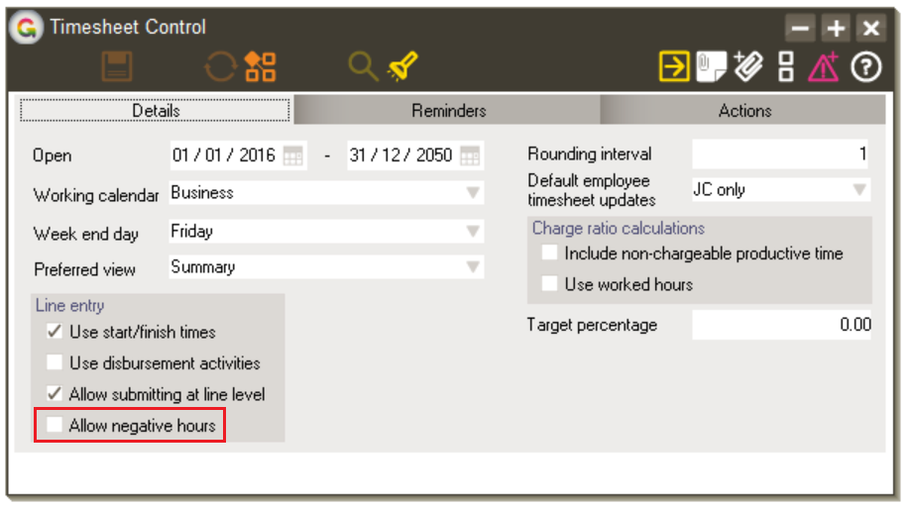
You can find the Mobile Timesheet Control form under System > System Setup > Mobile Timesheet Control in Greentree Desktop.

Finish Time on Timesheets Can Be After Midnight
We've changed JC timesheets to allow employees to enter finish times that are past midnight. For example, an employee could work a shift starting at 10:00 p.m. and which finishes at 6:00 a.m. the following morning. In previous versions of Greentree, the error message The start time cannot be later than the finish time displayed when an employee tried to enter a finish time that was after midnight.
This enhancement allows employees who work night shifts to correctly enter the time they work without resorting to workarounds. Employees can enter finish times that are after midnight on the following Greentree Browser forms:
- Call Time Entry – The time employees enter is added to or updated in the related Job Cost.
- Service Request Time Entry – The time entered is added to or updated in the related Job Cost.
- Mobile Timesheet – Employees can add the times on the Day grid and the Week grid.
- Employees can also enter finish times that are after midnight on the Greentree Desktop JC Timesheet Entry and Call/Service Request Time Entry forms.

Bug Fixes - Greentree Desktop
We've made the following fixes in Greentree Desktop:
- Greentree Desktop saves the retention value when you edit a proforma retention transaction and convert it to a JC invoice.
- 1090 errors no longer display when you:
- Click the Create Standing Order button on a Supplier Maintenance form that you opened by drilling down from a supplier code on another form.
- Try to cancel back-ordered quantities for serial or lot items.
- Clicking the From and To fields on Sales Order and Purchase Order Enquiry forms now highlights the contents of the field, enabling you to type in the field and to perform searches.
- A string too long error message no longer displays when you enter an email address longer than 32 characters on the Purchase Orders form in eRequisitions.
- Clicking the Clear icon on the Kitset Enquiry form now clears all fields and resets the form to its default settings.
- Quantity Breaks and Discounts are now correctly set on sales orders created through EDI.
- eHR leave requests that a user enters on behalf of another user now display the correct leave types.
- The error 1301 - Entry not found in Collection no longer displays when you change the posting date on a JC AR Credit Note.
- The Free function gtJCPlantCharge now supports U.S. dates.
- You can no longer use a job that has a status of Closed as a plant in JC Plant Job Entry.
- The GL Posting for a JC Retention write off now posts to DR JC Retention write off and CR JC Retention. You no longer need to manually correct the write off values in GL journals.
- Selecting the AR Statements parameter Open/Outstanding Only now only includes the remaining part of a partly-paid invoice in a statement, rather than the full value of the invoice.
- Selecting the Run Now option on the Task Scheduling form and then clicking Add to task queue no longer displays the Date must be specified message.
- In Sales Order Entry:
- The On Hold button is now available for sales orders with a status of Entered or On Backorder.
- You no longer need to refresh the form to enable the Hold button.
- The JC Revenue Recognition process now calculates the correct values for revenue estimates.
- Exception 1035 (String too long) no longer displays when the subcode on a purchase order entry line exceeds six characters.

Bug Fixes: Greentree Browser
We've made the following fixes in Greentree Browser:
- On saving a Browser timesheet, Greentree no longer incorrectly recalculates the hours on the timesheet's Day Detail tab.
- The Service Request Type now displays in the Service Request list and on Service Requests forms. The correct type is saved when you edit a call or service request.
- The message Unexpected error no longer appears when saving timesheet lines while using a touch-enabled laptop computer.
- Users now have three chances to enter their password correctly before getting locked out of Greentree Browser.
- A warning message displays when a user tries to log into Greentree Browser using an expired password.
- In Leave Balances, selecting an As At date greater than the last accrual date no longer displays the Forecasting is not permitted for this leave type error.
- When you edit a lead in Greentree Browser, the Assigned Team is no longer cleared when you save your changes.

