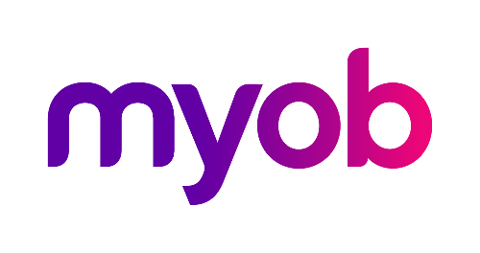
MYOB Greentree
Release Notes
2018.2.0

Contents
Introduction 1
Enhancements - Greentree Desktop 2
Customising User-Defined Fields in Windows Designer 2
Increased the Quantity/Hours You Can Enter into Timesheets for Calls and Service Requests 4
Australian Tax Reporting Changes 4
Before You Begin 4
Invoice Entry and Credit Note Entry Forms 5
Taxable Payments Report 5
Upgraded Microsoft C++ Redistributable Package 6
QlikView 12.10 Certification 6
Enhancements - Greentree Browser 7
Increased the Hours You Can Enter into Timesheets for Calls and Service Requests 7
Updated Permissions for Pricing & Availability in Greentree Browser 7
Bug Fixes - Greentree Desktop 9
Accounts Payable 9
Accounts Receivable 9
CRM 9
General Ledger 10
Human Resources 10
Inventory 10
Job Costing 10
Mobility 10
Various Fixes 10
Bug Fixes - Greentree Browser 12

Introduction
Release 2018.2.0 contains several enhancements to MYOB Greentree Desktop and MYOB Greentree Browser.
In Greentree Desktop, you can now move user-defined fields on a form you're customising in Windows Designer. We've increased the quantity or hours you can enter in timesheets for Calls and Service Requests. We've also made changes to Australian tax reporting for payments made to grant recipients.
In Greentree Browser, we've increased the quantity or hours you can enter in timesheets for Calls and Service Requests, and we've changed the security model around access to the Pricing & Availability module.
This release also fixes a number of bugs in both Greentree Desktop and Greentree Browser.

Enhancements - Greentree Desktop
This release of Greentree Desktop includes these enhancements:
- Customising User-Defined Fields in Windows Designer
- Increased the Quantity/Hours You Can Enter into Timesheets for Calls and Service Requests
- Australian Tax Reporting Changes
- Upgraded Microsoft C++ Redistributable Package
- QlikView 12.10 Certification

Customising User-Defined Fields in Windows Designer
When customising a form with Windows Designer, you can now move user-defined fields (UDFs) to any location on a form — whether on the current tab, or to another tab. You can also customise the properties of UDFs — for example, to make them read-only or mandatory.
To customise a UDF:
- On the Windows Designer form, select a customisation.
Click the Customised option to display only customised forms.
- Open the customisation.
- Find the list of the form's UDFs. This is usually in a table on the form's Custom tab. The table contains a row for each UDF.
- 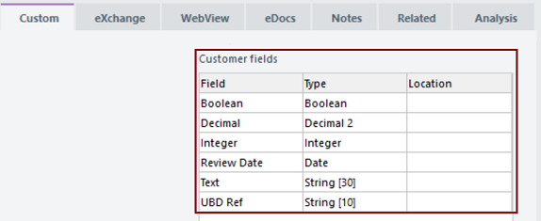
- Drag a UDF from the table to where you want it to appear on the form. This creates controls for the UDF on the form.
- For example, moving the Review Date UDF creates a date control, along with its label:
- Change the UDF's properties if necessary — for example, modify the UDF's position, size, or styling; or make it mandatory.
- Save the customisation.
- Click View in the Properties pane to review the customisation.
When the form is in use, the fields that you moved don't appear in the table listing UDFs on the Custom tab.
To find a UDF that you've moved, open the customisation in Windows Designer and click the Custom tab. Then, click the link in the Location column of the table to jump to the UDF:
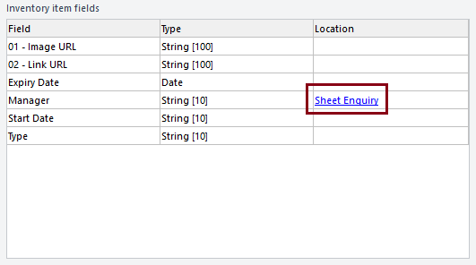
To return a UDF to the table, open the customisation in Windows Designer. Click the name of the form in the Properties pane, and then click Remove customisation in the menu that displays:
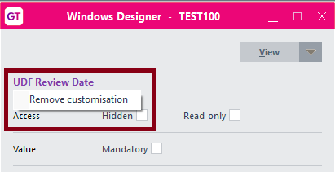

Customising UDFs on Forms Used by Multiple Companies
If you have the same UDFs set up on forms used by two or more companies in your environment, those UDFs appear on the forms for all companies. Windows Designer treats two fields with the same name and type in the same way.
If you have different fields across companies, you must check the customisation more carefully. When a customised form is in use, it only displays the fields relevant to the user's current company.
When editing the form, the table on the Custom tab displays fields for the company you're logged into, plus a row for each UDF you have moved that isn't used by that company. You must log in to different companies if you want to move UDFs used only by those companies.

Increased the Quantity/Hours You Can Enter into Timesheets for Calls and Service Requests
You can now enter a larger value in the Hours/Qty field on the Time Sheet tab of the Service Request and Calls forms. Previously, you could only enter a values between -99.99 and 99.99 in that field.
You can now enter a range of values from -999999.99 to 999999.99. This accommodates customers who use the Time Sheet tab to track not just hours worked, but also values like kilometres which can require a quantity above 99.99.

Australian Tax Reporting Changes
As part of Australian tax reporting requirements:
- Companies in the building and construction industry must report payments to contractors for services. This is a existing requirement.
- Government entities must report payments to recipients of grants. This is a new requirement.
We've changed to the AP Supplier Maintenance, AP Invoice Entry, and AP Credit Note Entry forms to comply with these requirements. We've also changed the AP Taxable Payment report.

Before You Begin
If you are paying contractors or grant recipients, you must select the Taxable Payment report required option on the Main tab of the AP Module Control form.

Supplier Maintenance Form
We've added the Taxable Reporting tab to the Supplier Maintenance form (found under Data Entry > Accounts Payable > Supplier Maintenance). We've moved the Taxable Payments Reporting options from the Defaults tab of the Supplier Maintenance form to the Taxable Reporting tab.
As well, we've added these options for payments that government entities make to grant recipients:
- Grant recipient - Select this option if the payee is receiving payments from a grant, and to report the payments in Greentree's Taxable Payments report.
- Grant name - Enter the name of the grant or the grant program from which the payee is receiving payments. This field is mandatory if you select the Grant recipient option.
- Statement provided - Select this option if the grant recipient has provided you with a Statement by a supplier form. The form indicates that the payee is not required to quote an ABN number.
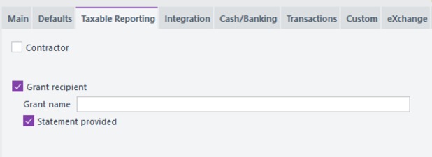
If you select the Statement provided option, Greentree adds an ABN that consists of zeroes to the file it generates to submit to the ATO when you run the Taxable Payments report.

Invoice Entry and Credit Note Entry Forms
We've added the Taxable Reporting tab to the AP Invoice Entry and AP Credit Note Entry forms.
For:
- Contractors, the tab contains these options:
- Materials only - Select this option to indicate that the invoice from the contractor contains no labour, or only incidental labour.
- Exclude - Select this option to exclude the transaction from the Taxable Payments report.
- Grant recipients, the tab contains this option:
- Grant payment - Select this option to include the payment in the Taxable Payments report.

Taxable Payments Report
The file that Greentree creates to submit to the ATO when you generate the Taxable Payment report now contains this information:
- A flag indicating the payment type (P for contractors, G for grant recipients).
- The date of the grant payment.
- The name of the grant or grant program.
- The supplier's email address.
- A flag indicating that the grant recipient provided you with a Statement by a supplier.

Upgraded Microsoft C++ Redistributable Package
Previous versions of Greentree Desktop relied upon the Microsoft Visual C++ 2008 runtime libraries. Microsoft no longer supports that version of the libraries, and we've updated Greentree Desktop to work with the Visual C++ 2013 runtime libraries.
To take advantage of this change, pack your site to Greentree version 2018.2.0. Once you've done that, you can uninstall the Microsoft Visual C++ 2008 runtime libraries by selecting Microsoft Visual C++ 2008 Redistributable in Uninstall or change a program under the Windows Control Panel.
Note: Before removing the Visual C++ 2008 runtime libraries, you should determine if any other software in your environment requires those libraries. Removing the old runtime libraries could cause other software to stop working.

QlikView 12.10 Certification
MYOB Greentree is now certified for use with QlikView version 12.10. Greentree models and integrations will work with this version of QlikView.
You can find the installation files and release notes for Qlik 12.10 in this folder on the MYOB Greentree FTP site:
/Greentree/Greentree IQ/Installation Files/QV12.10 SR

Enhancements - Greentree Browser
We've added these enhancements to Greentree Browser:
- Increased the Hours You Can Enter into Timesheets for Calls and Service Requests
- Updated Permissions for Pricing & Availability in Greentree Browser

Increased the Hours You Can Enter into Timesheets for Calls and Service Requests
You can now enter a range of values from -999999.99 to 999999.99 in the Hours field on the Time Entry tab of the Service Request and Calls forms. This accommodates customers who use the Time Entry tab to track not just hours worked, but also other values like kilometres which can require a quantity above 99.99.

Updated Permissions for Pricing & Availability in Greentree Browser
We've updated the permissions that users need to access the Pricing & Availability module in Greentree Browser. To get access to Pricing & Availability:
- The user's company must be licensed to use the Greentree Inventory module, and
- The user must have access to one of:
- Browser Distribution Suite, or
- Browser Client Enquiry, or
- Browser Client Sales.
To confirm that the company has access to the Inventory module, select System > System Setup > Company Maintenance. Then, click the Modules in Use tab and find Inventory in the left pane of the form.
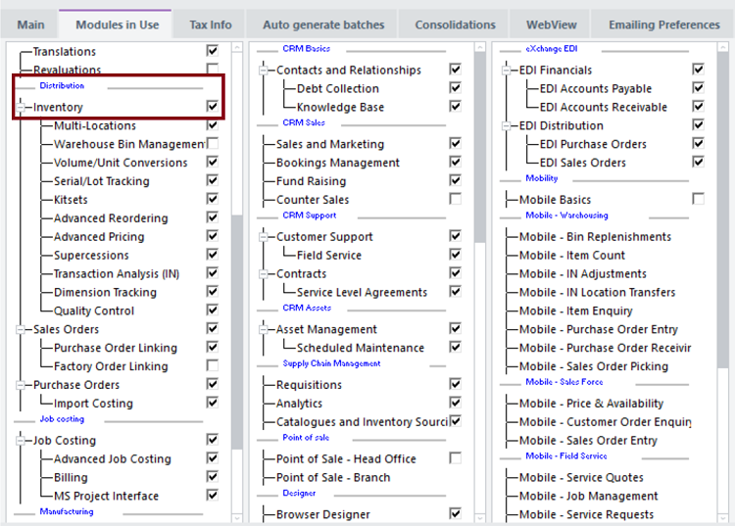
To confirm or grant access to users, select File > Preferences, click the Access tab, and then click the Suite sub tab.
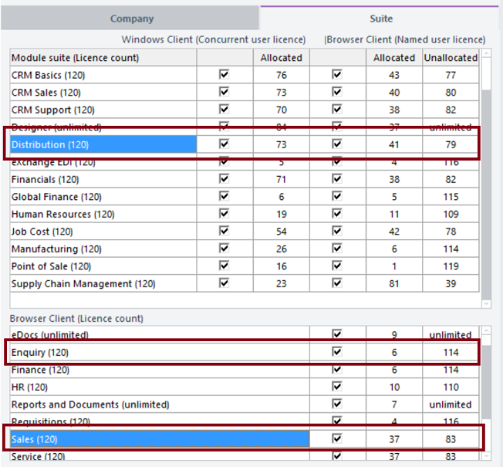

Bug Fixes - Greentree Desktop
We've fixed these issues in Greentree Desktop:

Accounts Payable
- Greentree Desktop now correctly displays and exports AP Supplier Maintenance transactions to XML (which you can open in Microsoft Excel).
- On the Transactions tab of the AP Supplier Maintenance form, the contents of the Tran and Reference columns in the table no longer display as Unapplied Transaction, UAPP.
- Error 14049 no longer occurs when displaying selected transactions in large collections on the Transactions tab of the AP Supplier Maintenance form
- The error Invalid number of rows set for Table no longer displays when you try to view all invoices for a supplier using AP Supplier Maintenance > Transaction Enquiry.
- When you import AP transactions using the Data Import Module, the values in the resulting AP credit note and in the general ledger are no longer out of balance.
- Error 1210 no longer displays when you save an unprocessed AP payment that has the same Selection Name as another unprocessed payment.

Accounts Receivable
- If the option Allow FREE to update last invoice number is selected in AR Module Control, the invoice number range in AR Module Control > Auto generate code > Invoice number now increments correctly when you update AR invoices using the FREE gtARInvoice function.
- When you apply or unapply transactions on the Apply Transaction form, the credit transaction displays with the correct credit note number.

CRM
- Autoscan no longer displays an error message when you try to save attachments to your workstation or to a folder on a network drive.
- When you apply background colours to tiles in the Workflow panel, Workflow Desktop icons are now visible and the colour you set displays on the tiles.
- HTML emails sent from the Debt Collection module now generate and display correctly.
- Error 1000 (Invalid parameter type) no longer displays when a Scheduled Rule exports a file that's used to interface with other systems.
- When an item on the Inventory Selling Price Maintenance form has rows for both local and foreign currency, the currency from the quote header (rather than the currency of the local price) updates into a CRM quote.

General Ledger
- We've fixed a problem in which Greentree was unable to process revaluations on a foreign currency bank account because there was no Cash Management Analysis code for the automated journal. In this situation, Greentree now uses the suspense analysis code from the Cash Management module control.

Human Resources
- You can now convert a JC employee to an HR employee if that person is also a Mobile Timesheet employee.
- Error 1301 no longer occurs when copying a terminated employee with an empty Bank Details user defined field in their record.
- Greentree no longer displays the error message User: XXXX had an error: Password must have a numeric and a special character in it if you try to create mobile employees from HR employees when Advanced Password Management is in use. Greentree now automatically generates complex passwords that contain special characters (for example, and &).

Inventory
- If you have Enquiry Access only privileges on the Price & Availability, Price, Cost and View Inventory Items forms, drilling down on an inventory item takes you to the Enquiry form and not the Inventory Maintenance form.

Job Costing
- You can now search for addresses using the Delivery address field on the Job Maintenance form.

Mobility
- We've removed the Pick List option from the pop-up menu on the Select Items to Pick form in the Greentree Mobility app.
- The Mobility app no longer displays An error has occurred (1011). The requested property is not defined for this object class when you try to put an item on back order.

Various Fixes
- If you're using the 64-bit Connection Manager with a version of Greentree before 2018.1.0, you can now access the Greentree Desktop online help. Ensure that the help files (which have the extension .chm) are in the Greentree \bin64 folder.
- We've reinstated the colour coding of the icons in the Select Property window for queries that you run from Explorer.
- Error 1310 no longer occurs when you add a new team to Greentree Desktop.
- We've included a fix that stops empty UTMonitorStatistics objects from being created. At some sites, a large number of those objects were being created and, while small, together they took up large amounts of disk space.
- When you select the Mandatory option for a form element in Windows Designer, users cannot move away from that element without completing the mandatory fields on the live version of the form.
- Selecting Send table contents to clipboard in the JADE Query results table now copies the contents of the table to your clipboard.
- We've fixed an issue in which changes to the HR Preferences form under File > Preferences were not being saved.
- When you select the option Allow manual linking of pays to leave requests on the Leave Planning tab of HR Module Control, you can link pay details to an HR Leave Request by selecting either the Allow manual linking of pays to leave requests or the Allow entry of pay details (not linked) options.
- Error 1300 - (Array index out of bounds) no longer occurs when you open the Company Maintenance form for an inactive company.
- Error 1215 - Persistent objects cannot reference transient objects no longer occurs when the Greentree EDI processor attempts to process an outbound AR invoice.

Bug Fixes - Greentree Browser
We've fixed these issues in Greentree Browser:
- When you add an organisation in Greentree Browser, the correct sales team (if there is one) for salespeople you add to the organisation now displays in the Team field on the Details tab.
- Jobs with work centre plans now show the plan description for that job's work centres. Greentree Browser no longer displays descriptions from the work centre record.
- Lines saved as timesheet lines in Greentree Desktop now display in Greentree Browser.
- When entering Sales and Service Quote lines, the Unit Price remains unchanged when you click between the Amount and Quantity fields.

