MYOB Greentree
Release Notes – Query Designer
2019.3.0

Contents
Introduction 1
Security 1
Components of Query Designer 2
Query Builder 2
View Builder 3
Query Results Viewer 4
Query Designer Manager 4
ODBC Exposure 5
Toolbox 5
Data elements 5
Runtime variables 6
Parameters 6
Permissions 6
Defining a Data View 7
Building a Simple Query 8
Adding Parameters to a Query 9
Advanced Options 10
Filtering Using the Collection Tab 11
Previewing a Query or a View 12
Viewing the Results of a Query 13
Using the ODBC Exposure Form 14
Exporting and Importing Queries or Views 15
Troubleshooting 16

Introduction
The Query Designer enables you to graphically build and format database queries — no scripting required. All you need to do is drag and drop properties (which correspond to fields in the database) and parameters into a query.
The results of your query display in an easy-to-read and understand format, which you can customise. You can save those results to an XML file and import data into an external reporting tool or a spreadsheet editor like Excel via ODBC.

Security
As a matter of course information returned from any query will apply all user and team based security to limit said information to only those records that the user is permitted to view.
You can use the Permissions panel in the toolbox on the Query Builder and View Builder forms to give specific teams and users permission to edit and/or run queries. This is explained in the section Toolbox below.
If you select the Limit Query Designer to current company only option on the Main tab of the General System Preferences form, queries will only return results for the company that the user is logged into. If this option is not selected, then queries will return results for all companies. In a query results table, lines for the current company are black, and lines for other companies are blue.
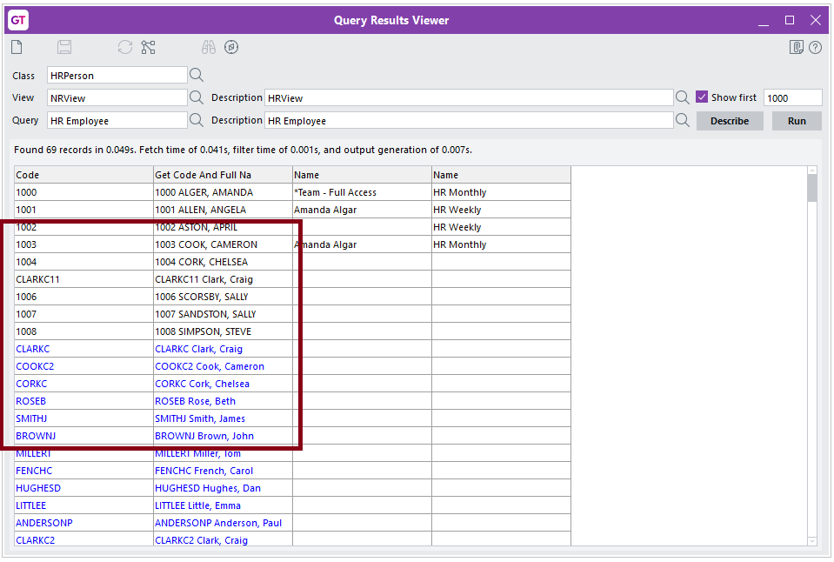
On the Query Builder and View Builder forms, the only teams that display in the toolbox are ones that do not have the Ignore for security settings option selected on the Team Maintenance form.
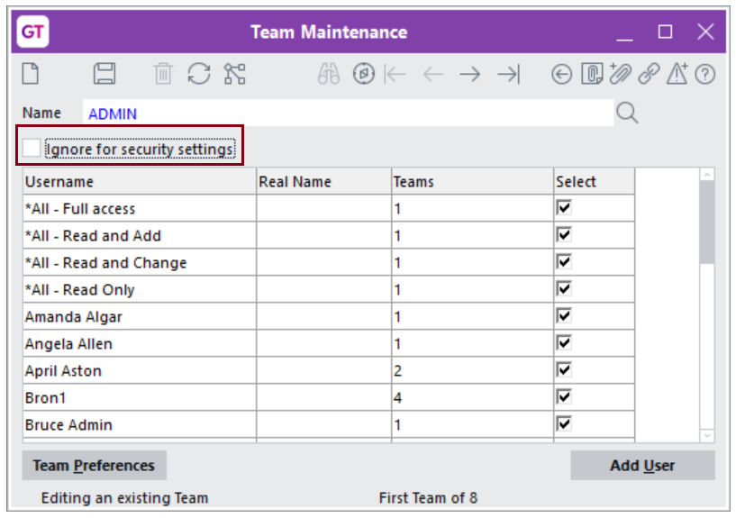
- Before you can use Query Designer to query HR tables in the database, you must select the Show HR Data in Explorer and Jade Query option on the Security tab of the HR Preferences form.

Components of Query Designer
Query Designer is made up of these forms:

Query Builder
Use this form to assemble the pieces of your query, to run the query, and to display the results.
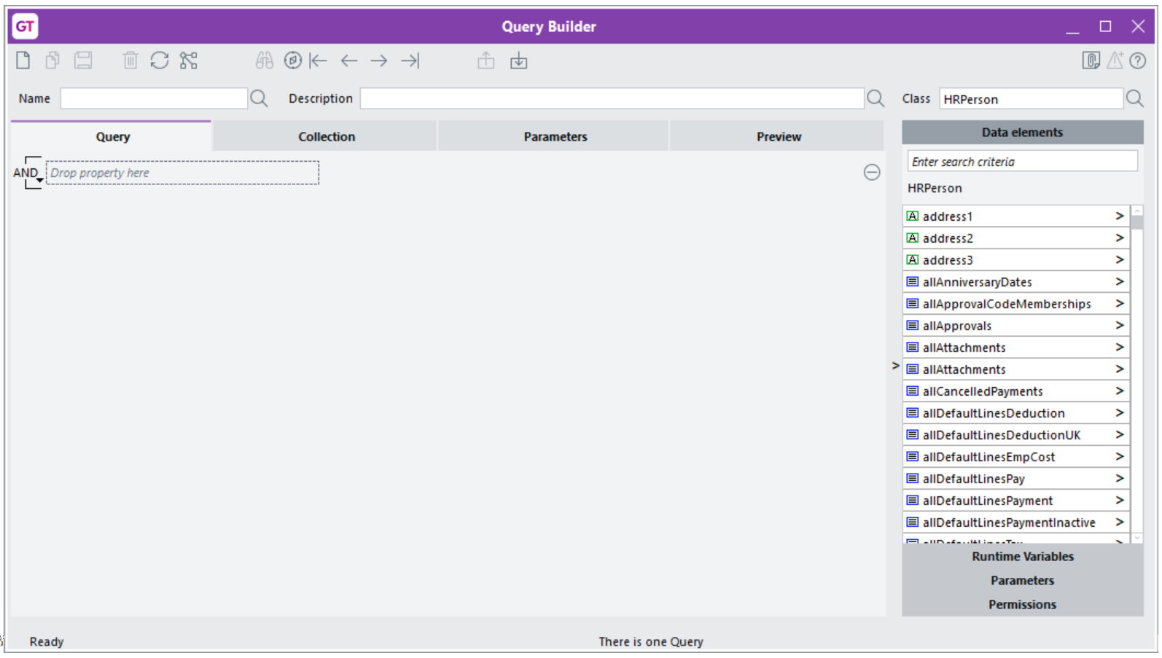

The Query Builder has these tabs:
- Query — Where you build the query.
- Collection — For advanced users. Enables you to determine how to access the list of records from various collections available in the database. Further filters can be applied here to improve performance when finding the information that you’re retrieving from the database.
- Parameters — Enables you to add parameters which you can use to further refine your queries.
- Preview — Displays a limited number of query results so you can check that the query is returning the information that you want it to return.

View Builder
Use this form to determine how to display your query results. You can also use this form to determine how to group and, where necessary, total the results.
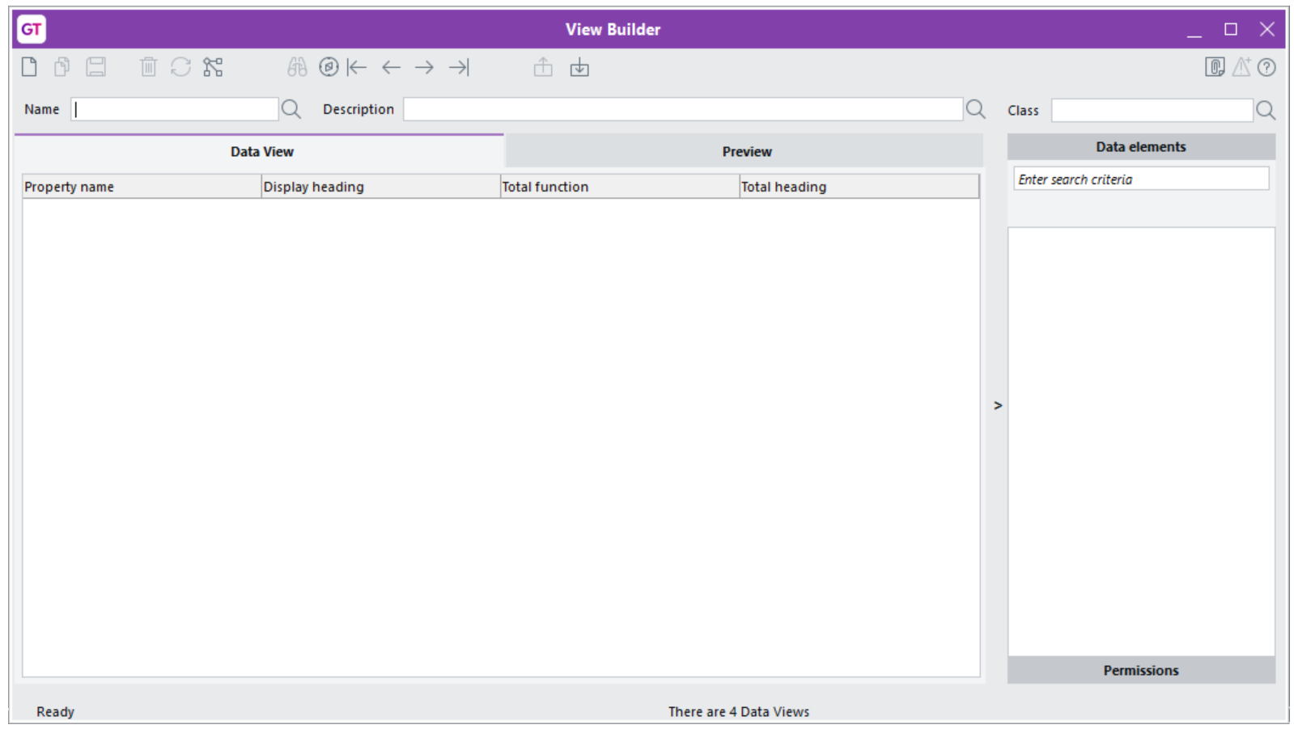
The View Builder has these tabs:
- Data View — Where you build the view.
- Preview — Displays a limited number of query results. Do that to check whether or not data displays in the way in which you want it to.

Query Results Viewer
Use this form to allow all users to run the queries that have been created for them[Scott – this form is aimed at Joe SixPack, while the builders are more for advanced users and admins so I’m sure you can wordsmith that concept better than me]. This is explained in the section Viewing the Results of a Query.
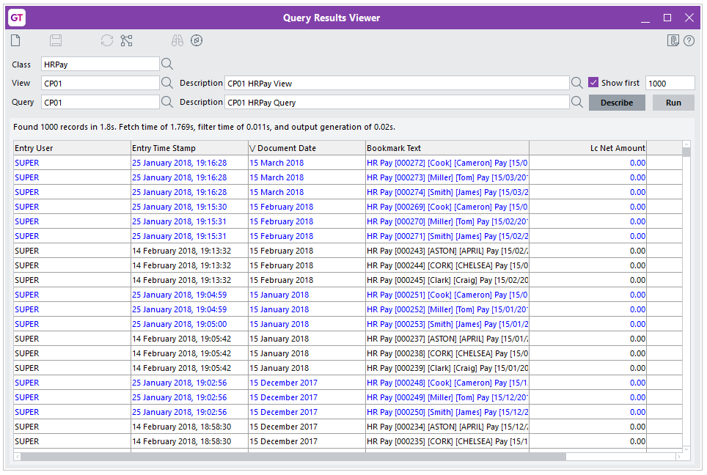

Query Designer Manager
Use this form to import or export queries as XML files. This is explained in the section Importing and Exporting Queries below.
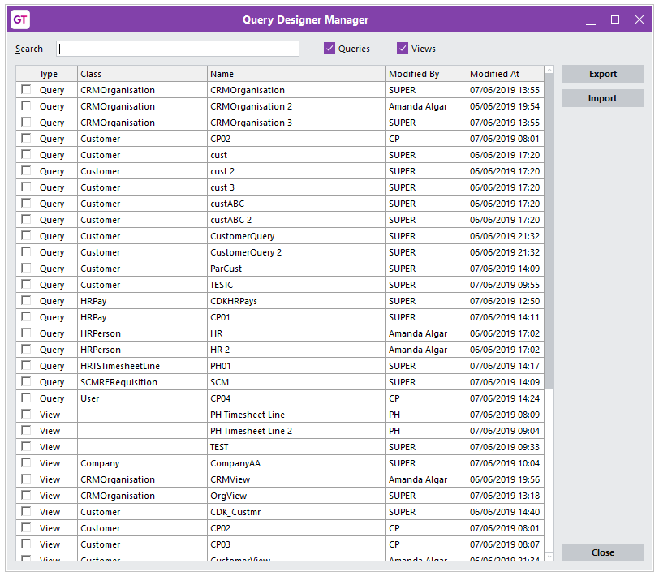

ODBC Exposure
Use this form to add a query table to the Greentree database. You can then use that table to pull data into a third-party reporting, spreadsheet, or auditing tool.
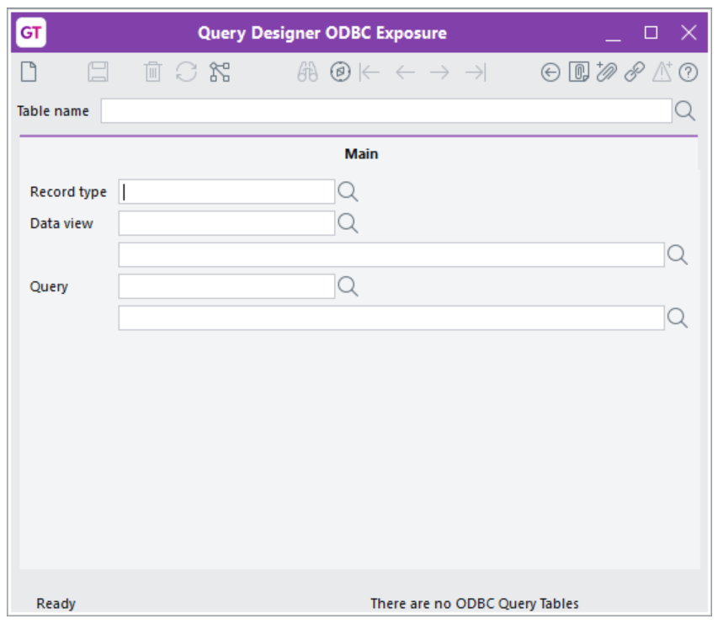

Toolbox
The toolbox on the right side of the Query Builder and View Builder forms contains all of the data elements, variables, and parameters that you can drag and drop into a query. It also enables you to control which teams and users can work with or run the query.
The toolbox consists of these panels:

Data elements
The database fields that you can use to create a data view or a query. [Scott I feel that more may be required here. Such as the right arrow navigating down a property path with that full path being displayed where HRPerson is shown below, bubble help to show the full path, and the context sensitive button for Back/Clear/Subclass. How the subclassing might work. Hint that typing user in the search criteria box for UDFs and tree for Trees]
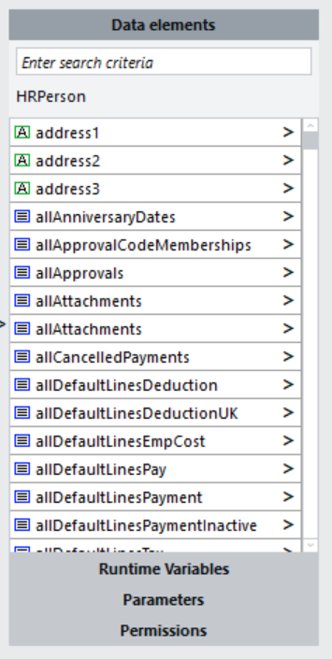

Runtime variables
Which enables you to add these variables to a query:
- This panel is not available on the View Builder form.

Parameters
A list of user-defined parameters that you can use with multiple queries. Parameters are described in the section Adding Parameters to a Query.
When you create two? parameters with the same description, but for different queries, give the parameters unique names. [Scott – Are you trying to say when creating a parameter give it a meaningful name] For example, if you’re setting up parameters to use with inventory items, create a parameter called stockcode instead of code. Any parameter values entered on a previous query run but for the same name will carry that value over.
- This panel is not available on the View Builder form.

Permissions
This panel contains two tabs: {#permissions}??
- Teams, which gives specific teams (and their members) in a company permission to run and/or edit queries.
- Users, which gives specific users in a company permission to run and/or edit queries, regardless of their team permissions.
You can click the Available for all users option to give all teams and all users in a company permission to view and run the queries.
By default (For new queries/views?) all users are able to run a query/view , however only the current user is ticked as allowed to edit them.
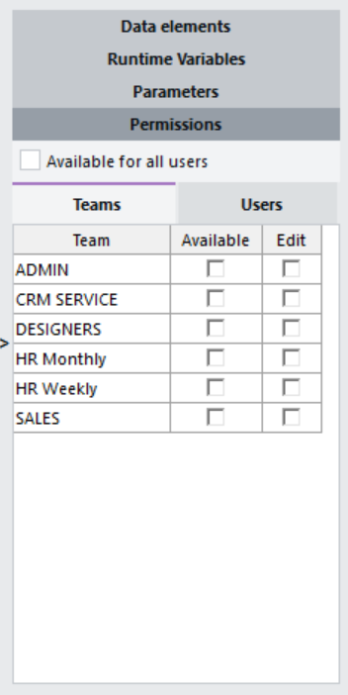

Defining a Data View
Use the View Builder to define how you want to display the data in a query. Data views are based around classes, which you can edit or create on the Class Maintenance form. You can use any existing classes, or define your own classes on the Class Maintenance form.
Each class has a set of properties, which display in the Data elements toolbox on the right side of the View Builder form. The data elements are components of a class. For example, if you’re building a query based on the Customer class, you can add the address1 and bankAccountNo properties to the view.
To define a data view:
- Select System > Utilities > Query Designer > View Builder.
- Select the record or class that will be the basis of the view from the Record type list.
- Enter a Name and, optionally, a Description for the view.
- Drag and drop one or more properties from the Data elements toolbox into the view.
- Use the search box at the top of the Data elements toolbox to find a specific element or to narrow down the list.
- Note: You can also select trees and user fields from the toolbox.
- If necessary, you can change the way in which the property appears in your query results by entering text in the Display heading column.
- For example, if you’ve added the property name to the data view, you can enter Customer Name in the Display heading field.
- If the any of the properties are numeric or date based — for example, a total — you can select a totalling function in the Total function column.
- You can select Total, Average, Maximum, or Minimum.
- 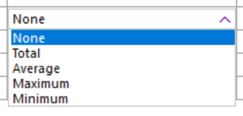
- If any of the properties are a date, you can sort items by date by selecting Earliest or Latest from the Total function column. [Scott - Just drop this one. It does not sort, it adds a Min (Earliest)/Max (Latest) in the totals section in the same way that numbers do. Default sorting is targeted for a future phase]
- Click Save.
Here’s an example of a data view that you can use with a query for organisations in the CRM module:
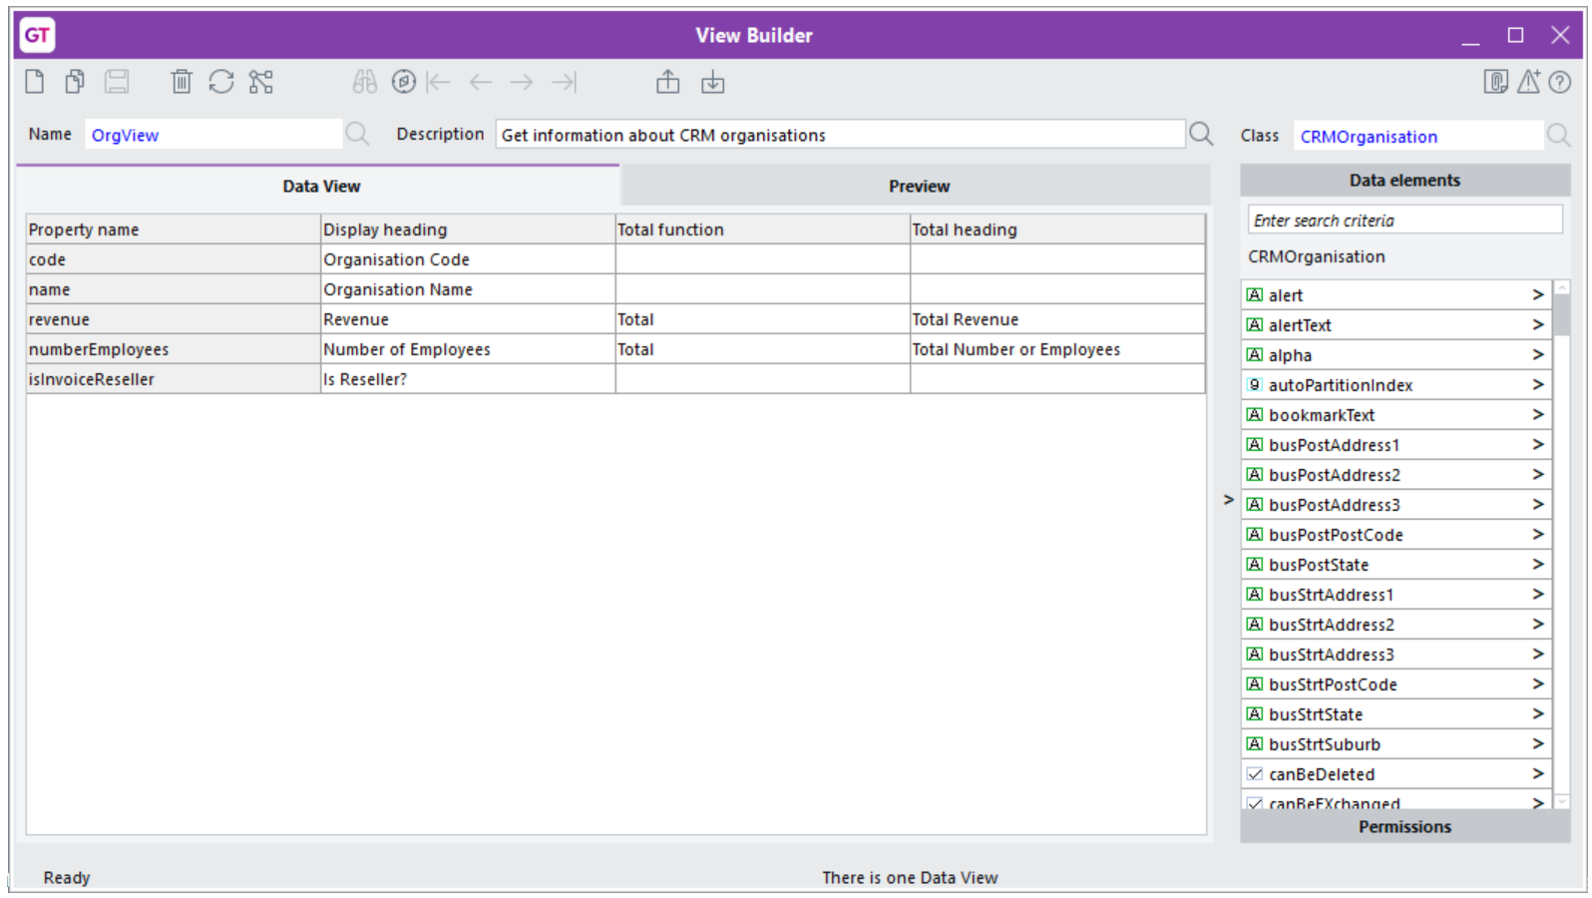

Building a Simple Query
Let’s build a simple query that retrieves reseller organisations from the CRM module (and which uses the data view illustrated above):
- Select System > Utilities > Query Designer > Query Builder.
- Enter a Name and, optionally, a Description for the query.
- Select a class on which to base the query from the Class list.
- For this example, select CRMOrganisation. The Data Elements panel of the Toolbox contains all database fields for the CRMOrganisation class.
- Drag and drop one or more properties from the Data elements toolbox into the query.
- Use the search box at the top of the Data elements toolbox to find a specific element or to narrow down the list.
- For this example, drag and drop isInvoiceReseller into the query. Click the dropdown list and select Is true. When you run the query, it returns all organisations that are resellers.

- You can also select trees and user fields from the toolbox. If you drag and drop a property from the toolbox on to one in the query, the property that you drop replaces the existing one. The list of options changes dynamically with the type of property dropped, trees are a special case where a separate dialog is used to select the tree branches to include in the filter.
- Click the + button on the right side of the query to add a placeholder for another property or element. Then, drag and drop the property or element on to the placeholder from the Toolbox.

Adding Parameters to a Query
You can use parameters to further refine your queries. You can, for example, add parameters that prompt you for information — like a customer code or a range of values — when a query runs.
To add parameters to a query:
- On the Query Builder form, click the Parameters tab.
- Click the New icon on the toolbar.
- Enter a descriptive name for the parameter in the Name the parameter field.
- Select type for the parameter from the dropdown list:
- Boolean
- Date
- Integer
- Decimal
- String
- TimeStamp
- When you select a type of parameter, you can choose a default value for it. For example, choosing Date or TimeStamp displays a date picker; choosing Boolean displays a dropdown list from which you can select True or False.
Each parameter you add displays in the Parameters toolbox on the right side of the form. You can include parameters in a query by dragging and dropping them from the Parameters toolbox to a query on the Query tab. You can use those parameters with other queries
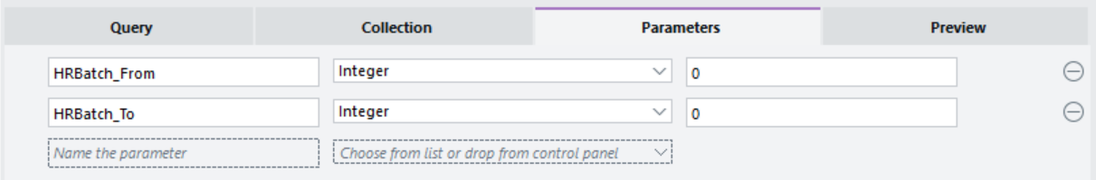
- If you drag and drop a parameter from the toolbox on to one in the query, the parameter that you drop replaces the existing one.
When you include a parameter in a query and run it on the Preview tab, Greentree will prompt you to enter a value for the parameter. Parameters will initially be set to the default values entered on the parameter tab. You can change these default values. Any other preview actions including those for a different query will attempt to apply any previous parameter values for a parameter with the same type and name. In this example, you enter a range of integers:
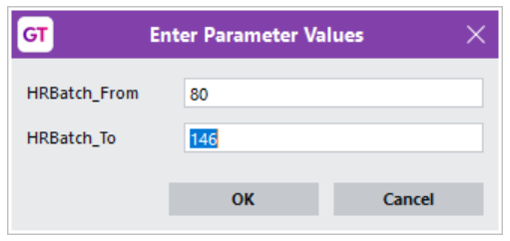
[Scott – You start by talking about CRMOrganisation, then flip to HRBatch. I wonder if building a query up might be a superior tactic?]

Advanced Options
The examples above are quite simple. Your organisation will undoubtedly require more complex and detailed queries.
You can add multiple properties to a query, but you can also apply AND/OR logic to properties in a query and nest properties.

Applying AND/OR Logic
Let’s go back to the query that retrieves reseller organisations from the CRM module. If you have many resellers, you might want to narrow down the number of results by retrieving organisations whose codes start with 10. To do that:
- Click the + button in the query.
- Drag and drop code from the Toolbox into the query.
- Select Starts with from the dropdown list, and enter 10 into the field.
- 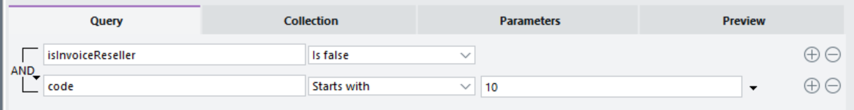
Note: You can add as many properties as you need to.
Notice the AND beside the properties in the query? You click the downward-pointing arrow and select Change And/Or. Do this to change the query to evaluate one property or another. Doing that can narrow down your results (Yeah…. Nah Changing to OR will generally widen the result set, I would suggest dropping this statement. Consider pen colour. I want Blue OR Red but no other colours which means you get additional pens (red) rather than fewer. Perhaps word it as a list of things as a for example such as Branch 01 or 02 or 03)

Adding Sub Groups to a Query
Sub groups enable you to nest properties in a query to further narrow down your results. You can add multiple sub groups to a property in a query. [Scott- I really don’t like this description. It feels like it doesn’t really capture what is happening. Sub-group is more akin to brackets, and it flips the AND/OR of the parent. It is not really nesting properties it is adding a bracketed sub condition. Sub-group can be taken to any depth so (cond1 AND (cond2 OR cond3)) etc but of course that is waaaay too technical. A better example might be the list of values again. Like branches viz (isInvoiceReseller AND (branch = Vic OR branch = NSW))
To add a sub group:
- Click the downward-pointing arrow beside the property to which you want to add a subgroup and select Add sub-group.
- Drag and drop a property into the query.
- For example, to include only companies whose names start with KA in the query results, drag the name property into the query, select Contains from the dropdown list, and enter Ka in the field.
- To add another sub group, click the downward-pointing arrow beside an existing sub group and then select Add sub-group.
- You can delete sub groups by clicking the - button on the right side of the query, or by clicking the downward-pointing arrow and selecting Remove this sub-group.
Here’s an example of a query that searches for resellers whose code starts with 10, and whose name starts with Ka or which have 20 or more employees:
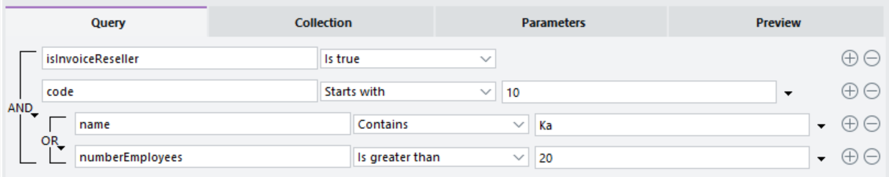

Filtering Using the Collection Tab
The Collection tab on the Query Builder form enables you to quickly and easily drill deeper into your database. You can, for example, narrow down the list of suppliers to those for a specific company.
Using this tab, you can choose the most optimal way in which to get information. With suppliers, for example, you can filter using a company or a calendar.
This tab uses the collections set up on the Class Maintenance form. The Source list suggests the most appropriate collection for your purposes, based on the company collection setup in the Class Maintenance screen. You can double click the Filter column in the table to add further filters. Note that the earlier a filter is applied the faster, in general, a query will execute.
You have these options:
- Suggested collection — If you select this option, Greentree lists the elements as they are listed on the Class Maintenance screen. For example:
- 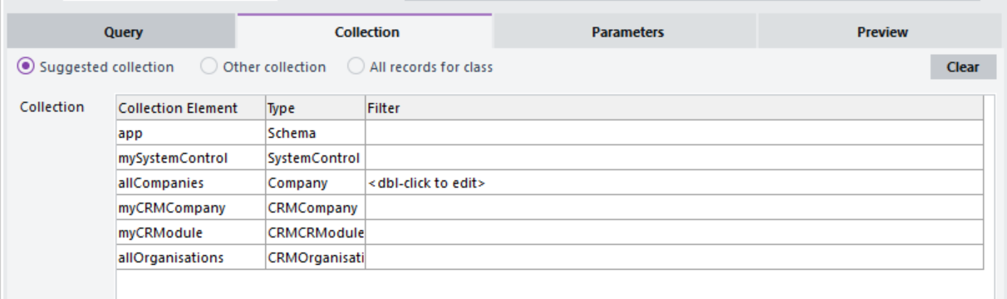
- Other collection — If you select this option, a form containing a list of all data elements displays. Select a collection and then click OK. [Scott - Typically select a path to the collection. The select path must end in a collection and contain records of the same Class as the query Class. This is enforced and an error dialog will display if not.]
- 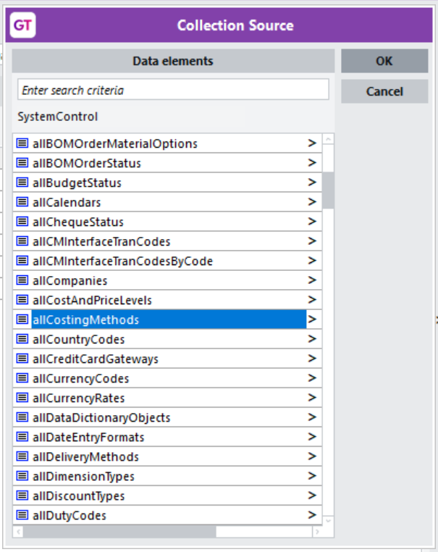
- All records for class — If you select this option, Greentree includes all records in the collection for all companies.

Previewing a Query or a View
You can preview a query or a view while you’re creating it to test that it’s working in the way in which you want it to. To do that:
- Select System > Utilities > Query Designer > Query Builder or System > Utilities > Query Designer > View Builder.
- Click the Preview tab.
- Select the class or view to preview from the Name dropdown list.
- On the Query Builder form, select a view from the Using View dropdown list.
- On the View Builder form, you can use the default selection in the Using Query list or select a query from the list.
- Click Run. The results of the query, display in a table on the form.
- 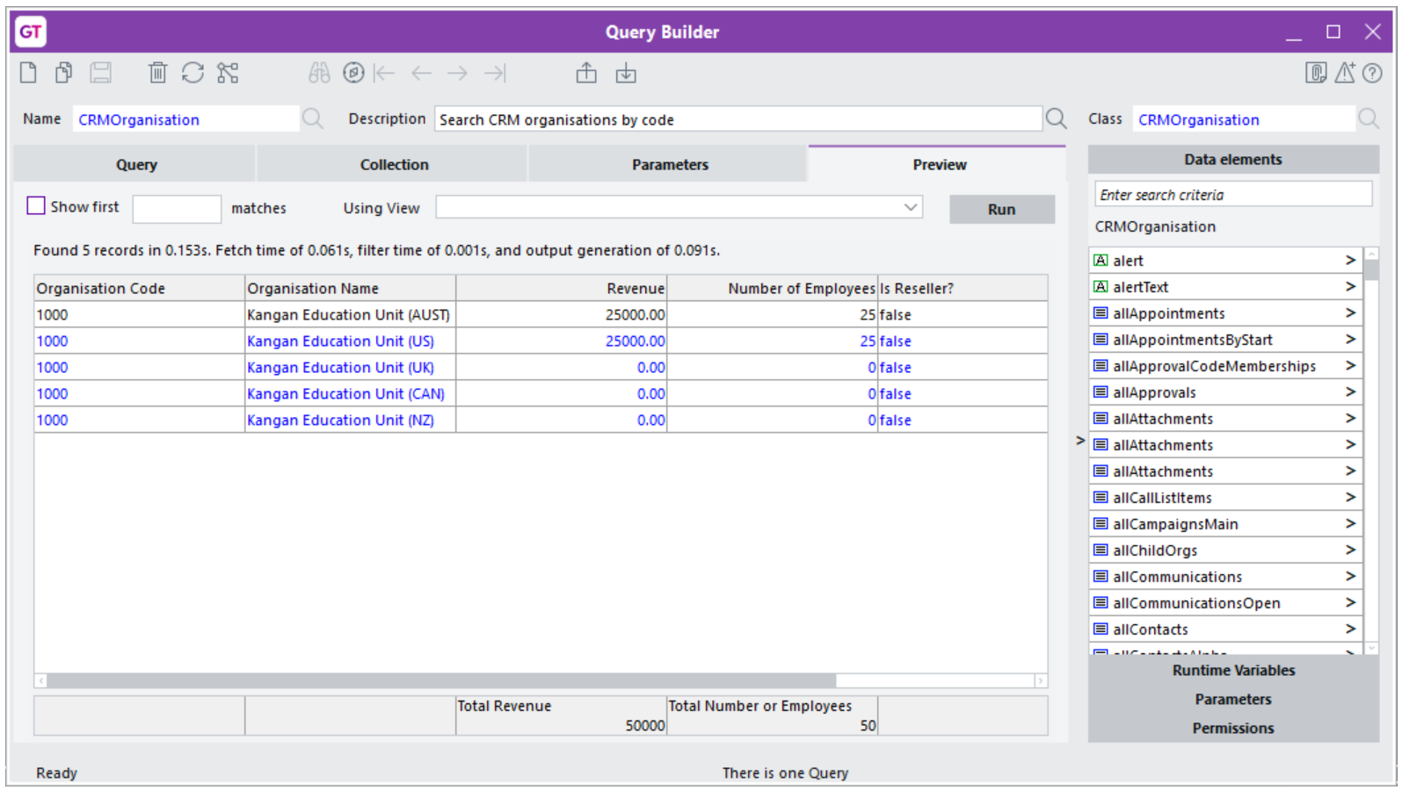
The table displaying the results is similar to a clever table. You can, for example, export the contents of a table in these file formats:
- XML
- HTML
- CSV
- Text
You can also copy the contents of the table to your workstation’s clipboard and paste them into an application like Word or Excel.

Viewing the Results of a Query
Use the Query Results Viewer form to selectively run queries and view or save the results.
To view the results of a query:
- Select System > Utilities > Query Designer > Results Viewer.
- Select a class from the Class dropdown list.
- Select a view from the View dropdown list. This is mandatory.
- Select the query to run from the Query list.
- Click Run.
The results of the query display in a table on the form. Right click on the header of the table and export the contents in these formats:
- XML
- HTML
- CSV
- Text
You can also copy the contents of the table to your workstation’s clipboard and paste them into an application like Word or Excel.
- Click the Describe button to view the code that makes up the query — for example:
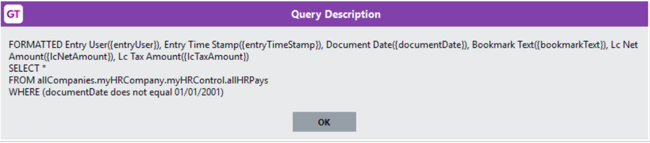

Using the ODBC Exposure Form
Use the ODBC Exposure form to add a query table to the Greentree database. That table exposes queries to external applications, and you can use the table to pull data into a third-party reporting, spreadsheet, or auditing tool like Microsoft Excel.
To use the ODBC Exposure form:
- Select System > Utilities > Query Designer > ODBC Exposure.
- Enter a name for the query table you’re creating in the Table name field.
- Select the record on which to base the table from the Record type list.
- Select the query view to use from the Data view list.
- Select the query to use from the Query list.
- Click Run.

Exporting and Importing Queries or Views
You can save queries or views your hard drive or a location on your network as one or more XML files. You can, for example, export a query or a view from one instance of Greentree and import it into another. This eliminates the need to manually recreate queries and views across all of your instances of Greentree.

Exporting a Query or a View
To export a query or a view:
- Select System > Utilities > Query Designer > Query Designer Manager.
- Select the query or view that you want to export by clicking the checkbox beside its name.
- You can select multiple queries or views to export, or right click in the top-left corner of the table and click Select All.
- Click Export.
- Select a directory into which to save the file and click OK.
- Greentree saves the XML file, with the name of the query or view as the file name — for example, InactiveEmployeesQuery.xml.
- If you export multiple queries or views, Greentree saves each of them as a separate file.

Importing a Query or a View
To import a query or a view:
- Select System > Utilities > Query Designer > Query Designer Manager.
- Click Import.
- Select the file or files containing the queries or views that you want to import.
- Click OK.
- Greentree Desktop compares the names of the queries and views you are importing with those of your queries and view, and warns you if an existing query or view has the same name as one you are importing.
- 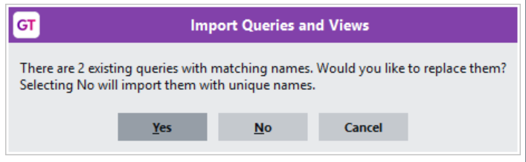
- Click Yes to overwrite the existing query or view; click No to import the query or view with a name that Greentree assigns to it; or click Cancel to stop the import.
When you do a bulk import, Greentree Desktop displays:
- The number of queries or views that you’re importing.
- The number of queries or views with names that match existing ones (if any).

Troubleshooting
If you run the query while the print and task queue is not running, this message displays:
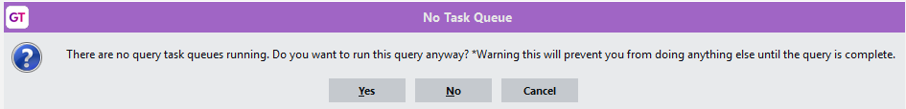
To proceed, click Yes. You must wait for the query to complete before you can do anything else.
When you want to create a query but have an existing one open, you may have to click the Clear button on the toolbar of the Query Builder form twice: the first click clears the query, and a second click may be required to clear the class search field.

