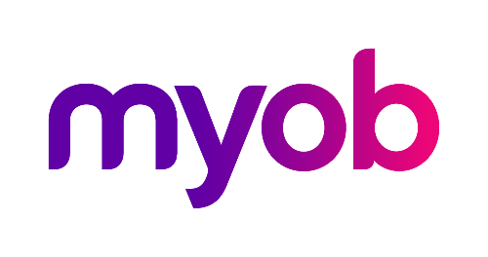
MYOB Greentree
Release Notes
2021.2.0

Contents
Introduction 1
Upgrade Notes 1
New Features 2
Desktop – Payment Times Reporting 2
Who Needs to Report Payment Times? 2
Enabling Payment Times Reporting 3
Setting up Suppliers for Payment Times Reporting 3
Effects on AP Invoices 4
Generating the Payment Times Report 5
Desktop – Search 10
Global Search on Desks 10
Search on Workflow Panels 11
Desktop – Date of Birth Checks 12
Desktop – New User Option 12
Desktop – Interface Updates 13
Desktop – Report Writer Attachments 14
Desktop – Leave Reporting Update 15
eDocs – Interface Updates 15
Saving Selection Criteria 15
Merging eDoc Payment Selections 16
Security Updates 17
Performance Updates 17
Resolved Issues 18
Greentree Desktop 18
Greentree Browser 20
eDocs 20

Introduction
The 2021.2.0 release adds support for the Payment Times Reporting Scheme in Australia, and adds a range of enhancements and improvements to system usability, performance and security. This release also addresses a range of issues identified in previous releases.
The sections below provide full information on all of the changes included in this release.

Upgrade Notes
- The new Packman 5.2 is required for 2021.2.0 and later, and supports 2020.5.0 onward. Copy the two files to the site’s bin64 directory before applying the Greentree 2021.2.0 package.
- The eModules update comprises security enhancements for eApprovals, eCRM, eHR, eRequisitions, eService and eTimesheets. Follow these steps to apply the update:
  - Zip up the current contents of the eModules virtual directories on the web server and retain them in a secure location.
  - Do not remove all files in the eModules directories - these contain vital configuration files.
  - Extract files from the eModules update 7z file.
  - Copy the files to the eModules directories, replacing existing files with the same name.
- WebView – New VRD files are mandatory for 2021.2 that use WebView
  - Zip up the current contents of the WebView directory which contains the cgi-bin and vrd folders used by the production system, retain them in a secure location.
  - Extract the Webview2021.2.7z file to a natural location. It will contain a new vrd and cgi-bin directories.
  - Copy the newly extracted vrd directory to the WeView directory of your production system, replacing existing folder and files with the same name.
  - Do not override the files in the WebView cgi-bin directory - these contain vital configuration files.
- gtSOAPHlp.dll – We have re-instated the 32-bit version of this DLL. The 32-bit version is for use on the IIS Server and is registered as a COM server per the current set of instructions; the 64-bit version will be used by default on the Jade Server. For current installations, no change is necessary. This has been done due to a site that migrated their IIS server and attempted to use the 64-bit version for that migration.
- DynaPDF – Version 4 is included in this release. It was included to correct an issue with barcode printing and it requires spaces removed from the report writers barcode printing. method.

New Features

Desktop – Payment Times Reporting
The Payment Times Reporting Scheme (PTRS) is a method of reporting to the Australian Government Department of Industry, Science, Energy, and Resources (DISER) based on the time taken for a large business to make a payment to their small business suppliers. This release adds features to MYOB Greentree to support Payment Times Reporting.
- For more information, see “Payment Times Reporting Scheme” on the DISER website.

Who Needs to Report Payment Times?
Only Large Businesses need to perform this reporting, and only on bills they have received from the Small Businesses they deal with. A Large Business is defined as a business that:
- earns over $100m in revenue for the last financial year, or;
- is part of a group that has earned over $100m for the last financial year, and this company earns more than $10m, and;
- is registered to operate in Australia.
A Small Business is defined as a business that:
- has annual revenue <$10mil, and;
- is registered to operate in Australia, and;
- is registered on the DISER tool for small businesses.
The Payment Times Reporting Scheme commenced on 1 January 2021. It requires businesses to submit a report on their payment terms and practices. Reports are due each six months of an income year, within three months of the end of the reporting period. The first reporting period is therefore 1 January 2021 – 30 June 2021, with the first report due by 30 September 2021.
PTRS reports are uploaded to the Payment Times Reporting Portal website. You will need a myGovID to log in to the portal. The PTRS report consists of two files:
- The PTR Template, which is a CSV file containing data on all of your payment information. MYOB Greentree produces this file—see “Generating the Payment Times Report” on page 5.
- The Responsible Member Declaration Template, which is a Word document containing signatures and associated declarations. The template for this document can be downloaded from the Payment Times Reporting Portal website—look for the Download PTR Responsible Member Declaration Template link on the home page.
See the page “How to report” for information on how to log in and complete the PTRS report.

Enabling Payment Times Reporting
If you qualify as a Large Business, you must activate the PTRS features on the Main tab of the AP Module Control window. Tick the Required to Report under PTRS box if you are a Large Business who is required to report payment times.

Setting up Suppliers for Payment Times Reporting
Once PTRS features have been enabled, you can set PTRS options on Supplier accounts. A new PTRS Small Business option is available on the Defaults tab of the Supplier Maintenance window:
You can tick this box manually if the Supplier qualifies as a Small Business, or it can be set automatically by the Payment Times Reporting tool—see “Generating the Payment Times Report” on page 5.
- To be included in PTRS reports, suppliers must have an ABN recorded. Before generating PTRS reports, review your supplier accounts and ensure that they have ABNs.

Effects on AP Invoices
A new Received date field is available on the AP Invoice Entry window, so you can record when you received the invoice for PTRS reporting. This field defaults to the invoice date, or, if the invoice was imported from an email via eDocs, the date when the email was received. You can also edit it manually if necessary. The field is always available, even if PTRS features have not been enabled.
- It is your responsibility to ensure that all invoice dates are entered correctly.
The PTRS report takes into account any supply chain finance agreements, i.e. discounts for prompt payment of invoices, you have with any of your suppliers. An invoice is considered to be included in a supply chain finance agreement if its payment terms (selected in the Terms field) have a prompt payment discount specified on the Payment Terms Maintenance window, i.e. if a value other than “No discount” is selected under Prompt payment:

Generating the Payment Times Report
A new Payment Times Reporting utility is available at Process > Accounts Payable > Payment Times Reporting. The utility lets you enter the necessary details and generate a PTRS report file, which can then be uploaded to the Payment Times Reporting Portal website.
The utility also lets you verify and update which suppliers count as Small Businesses for PTRS.
The basic workflow for using the utility is:
- Open the Payment Times Reporting utility and click Export to generate a CSV file containing the ABNs entered for all suppliers in your system.
- Upload this file to the Small Business Identification tool on the Payment Times Reporting Portal website.
- The Small Business Identification tool will return a CSV file containing only those ABNs from your export file belonging to businesses that count as Small Businesses under PTRS. Return to the Payment Times Reporting utility and click Import to import this file into MYOB Greentree. This will automatically tick the PTRS Small Business setting of all suppliers whose ABNs are included in the import file.
- Enter all required details into the tabs of the Payment Times Reporting utility (see the sections below), then click Create on the Report tab to generate the PTRS report CSV file.
- Upload this file and the Responsible Member Declaration Template file to the Payment Times Reporting Portal.
Details on the Payment Times Reporting utility are divided across four tabs:
- Company Details
- Payment Details
- Arrangements
- Reporting
Most of the details you enter will stay the same from reporting period to reporting period, so a save button is available to save the contents of each tab for future use.

Company Details
This tab contains details of your company and details of the corporation or group that it belongs to, if any.
The Business Industry Code is the Australian and New Zealand Standard Industrial Classification (ANZSIC) code for your company. To find your ANZSIC code, see the Business industry code tool on the ATO website.

Payment Details
This tab contains information on the standard, shortest and longest paying periods offered for inclusion in your contracts with your Small Business Suppliers.
- If any of these values change from one reporting period to the next, you must include information on the change(s) in the relevant Details of Change field.

Arrangements
This tab contains descriptions of the invoicing arrangements you have with your Small Business suppliers. Fields to describe your supply chain arrangements (if any) are also available.

Report
This tab contains the details of the people submitting the PTRS report and the dates that the report covers.
The Submitter, Approver and where applicable, Principal Governing Body details should be entered before you create this report. The Report Start Date, Report End Date, Approval Date, Declaration Date and File location are all required before the report can be generated by clicking Create.
- Saving the report saves all details on this tab except for the report start and end dates—these must always be entered manually before generating the report.

Desktop – Search

Global Search on Desks
Global Search is now available in the Toolbox on the Desktop Designer window:
Adding a Global Search pane to a desk lets users of that desk access the Global Search function quickly and easily:

Search on Workflow Panels
A Show text Search property is now available for 3D workflow panels and Masterfile/ Transaction workflow panels:
When this property is ticked, the panel will display a Search field below the existing icons:

Desktop – Date of Birth Checks
Employees’ date of birth details are optional; however, if you are claiming JobMaker Hiring Credits in Australia, a date of birth must be supplied for all employees who qualify for the credit. This release adds checks around employees’ date of birth:
- When an employee record is saved, a warning message appears if the date of birth is not filled in. This warning can be disregarded—the date of birth is still optional—but it will appear each time the employee record is saved.
- On the STP Lodgement window, if any employees in the submission are missing a date of birth, an error message will appear. In this case, the date of birth is not optional—you must enter a date of birth for all employees included in the STP submission before you can proceed with the lodgement.

Desktop – New User Option
A new Allow update of customer delivery details option is available on the options tab of the Sales Order Preferences window:
This option available if the user does not have the Financial module selected in their user preferences. When the option is ticked, users who are not Financial users will be able to edit the customer’s delivery address when editing a sales order. The option is unticked by default, preserving the functionality from previous releases.

Desktop – Interface Updates
- The styling of the frequently used input fields in data entry grids has been enhanced. Unnecessary borders have been removed, giving a clearer, flatter appearance.
- Drag and drop functionality is now supported from Outlook/Explorer, so you can drag and drop emails or individual attachments from Outlook and files from the Explorer window onto MYOB Greentree records.
- The release removes a warning message that could appear when logging in as Super or a user flagged as Admin for Total Secure. This message offered no options and did not affect the login—its removal speeds up the login process in these cases.
- Finalised jobs are no longer available for selection on the AR Invoice Entry, AR Credit Note Entry and AR Credit Note Creation windows. This prevents users from selecting a job that cannot be posted to, which would otherwise cause an error.
- You can now deselect a tree that a record has been added to directly from the tree selection window. A new Deselect button is available on the selection window—click this button to remove the record from the tree:

Desktop – Report Writer Attachments
The Report Writer has been enhanced so that images attached to masterfile records can be added to reports. This new feature can be used from both the old and new Report Writers.
- The Report Writer version has been increased to 1.32, which means that reports exported from systems at 2021.2.0 or later cannot be imported into Greentree systems at earlier versions.
When adding a picture field to a report, the Select Picture window (previously the Picture Library window) now includes options to source the picture from the Picture Library or from an Attachment:
The Property defaults from the Report Writer selection that the picture field is being added to e.g. SOPSINLineItem. You will then need to click Select Property to choose the record type that the image is attached to (myStockItem in the example above).
When Attachment is selected, you can select the type of attachment to use: Any, Image, Photo or Signature. The system will use the attachment of the selected type that has the Primary option selected. The picture field can be moved, resized and have a border added, as in previous versions.
- Make sure that image attachments are of a suitable size and proportions to appear in the picture field without distortion.

Desktop – Leave Reporting Update
NZ companies only
This release adds the HR Leave Rate Comparison report. This report lets sites compare the amount paid to an employee for FBAPS leave to the employee’s standard hourly rate (the report is generated for any Pay Tran Type where the Relevant or Average Daily Pay option is ticked). This allows you to make sure that the employee is not being paid less than their hourly rate.
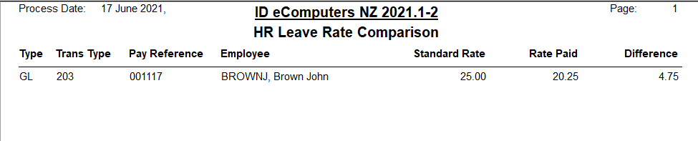
Report parameters are available to customise the report’s behaviour:
- Hourly rate only – If ticked, the report includes the hourly rate only. If unticked, the report will include allowances or other items from the default pay.
- Show all – If ticked, the report lists all employees, regardless of whether or not there is a variance. (Unticked by default, so that only employees with variances are shown.)

eDocs – Interface Updates

Saving Selection Criteria
The eDoc Payment selection form has been enhanced to allow you to save Selection criteria. Three new buttons have been added to the Invoice Selection tab:
- Save Criteria
- Delete Criteria
- New Criteria
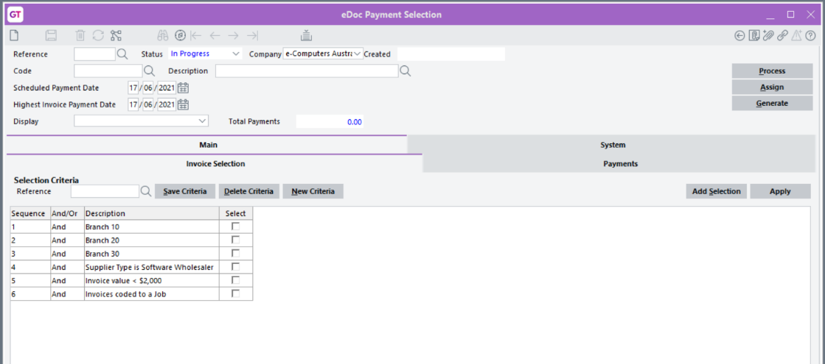
You can choose any combination of Selections, then save that combination with a unique Reference for future use.

Merging eDoc Payment Selections
Multiple eDoc Payment selections can now be merged into a single AP Payment selection, regardless of the eDoc Payment Selection Code.
The Type Maintenance window for the for Payment Selection type (System > eDocs > Type Maintenance) has a new Generate Option called “Select and Append”:
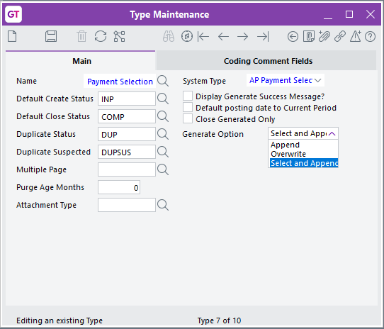
When the new option is selected, the eDoc Payment can be merged with an existing AP Payment. This is done via a popup window during the generation of the eDocs Payment:
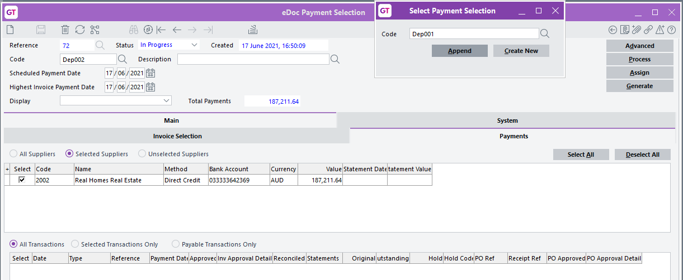
Two buttons are available on the window:
- Create New – Creates a new AP Payment without any merge.
- Append – If you select the Code of an existing AP Payment, you can use this button to merge your eDoc Payment to the selected AP Payment. The result is a Payment selection that contains the combined total and selections from relevant eDoc Payment selections.

Security Updates
This release includes several updates that increase the security of the MYOB Greentree system. These include:
- Improvements have been made to eModules security. New eModules resources need to be applied to replace existing resources on web servers.
- WebView's session ID is no longer passed as a URL parameter.
- Due to this change, you must also update the WebView VRD and eModules files directly after upgrading to 2021.2.0. These files will be available via FTP.

Performance Updates
This release includes the following performance enhancements that improve the speed and reliability of the system:
- Enhancements to improve the loading time of the AR Direct Debit window.
- Improvements to WebView performance when drilling down on large jobs, to avoid crashes that could occur in previous versions.
- Improvements to eRequisitions performance when using the Add Line or Save Line functions.
- When importing an eDoc, the system now creates a single attachment record, where previously it would create two: one for the eDoc and one for the converted document. This improves system efficiency without affecting functionality.

Resolved Issues

Greentree Desktop
We’ve fixed these issues in Greentree Desktop:
- With Greentree 2021.2.0n we’re releasing Packman version 5.2. This has a fix for an issue with determining the system size and disk free space that was leading to spurious warning messages. It also suppresses disk space checks in unattended mode. The new Packman version is required for applying packages 2021.2 and later, and is supported from 2020.5.0 onward.
- Where Advanced Security was used, users with “Team only” access could create, edit and view AR Receipts, and AR & AP Standing Invoices for all Customers and Suppliers.
- The error message “1090: Attempted access via null object reference error” could occur on the JC AR Credit Note Entry window when changing the date to a different period. This has been resolved.
- A fault introduced in the 2020.4.0 release where the Quiesce setting on database backup tasks was being ignored has been fixed.
- When opening the SO-PO Link Form from a read-only purchase order, it was possible to change the Linking Qty, but the change wouldn’t be saved. This has been resolved; the Linking Qty field is now read-only.
- The error message “The quantity cannot be less than the sum of QtyBO, QtyInv, QtyCanc and QtyPkd, the quantity has been Adjusted to the sum of QtyBO, QtyInv, QtyCanc and QtyPkd” occurred when reducing the quantity of a sales order when it was fully backordered. This has been resolved.
- After updating an HR employee’s anniversary date then making more changes, the employee’s details could not be edited—the error “Next Anniversary date must be at least one year later than the last anniversary date” appeared. This has been resolved.
- In some cases, the AH.dat file couldn’t be compressed. This has been resolved.
- When user access to the HR suite was removed, users still had access to Explorer and Jade Query as well as some Browser functions. This has been resolved.
- In some cases, Jade Query could allow users to access HR Classes when they shouldn’t have been able to. This has been resolved.
- Emails that include Cc and Bcc were not diverted when the Is a Test System option was ticked on the General System Preferences window. This has been resolved.
- If a desk panel containing a table was set up to sort the table by a dynamic property, the table would not be sorted when the desk was loaded. This has been resolved.
- The error message “1090: Attempted access via null object reference error” could occur when a entering a new leave request from the HR Leave Planner desk, if no Default Leave Type had been selected on the Leave Planning tab of the HR Module Control window, or if the selected leave type was not a type set up for the employee on the Balance Tracking tab of the Employee Maintenance window. This has been resolved.
- The error message “Could not calculate Standard Pay: Persistent objects cannot reference transient objects” could appear when clicking the Leave Balances button on the HR Employee Maintenance window, for employees who had a reducing deduction set on the Payroll > Deductions tab. This has been resolved.
- The Data Import Manager failed to trigger A&A rules for the "On Data Import" programmatic event. This has been resolved.
- In some cases, when the View dropdown on the HR Module Control window’s General > Main tab was set to “Team”, a 1086 error would appear when accessing the HR Employee Maintenance window. This has been resolved.
- Barcodes did not display when output to PDF in 64-bit PDF Reader. This has been resolved.
- The old barcode format was ‘*<space>123456789<space>*’—this must to be changed to ‘*123456789*’. Some reports use a method that takes a separator parameter; these reports will need to be updated.
- An error occurred if a Query or View assigned to the ODBC Exposure had been deleted. This has been resolved; Queries and Views can no longer be deleted if they have been used in a Query Designer ODBC Exposure.
- Minor changes have been made to the new Greentree installation system so that the database server and application server communicate via hybrid pipe shared memory (HPSM,) which supersedes the previous JadeLocal scheme.
- This release corrects an issue where the Allowed in Timesheets setting on the Pay Transaction Type was not enabled for systems without Job Cost. This prevented administrators from accessing Pay transaction types in Browser Timesheets.
- This release restores the functionality of the Debug Extract Log button on error screens.
- When AutoScan was turned on and a user tried to create a sales order from a quote, a 1400 error code occurred. This has been resolved.
- This release will detect and remove any existing orphan Instant Alerts in the system.
- Communications created via Outlook to Greentree Inbound Emails were not created in the company that the contact belonged to. This has been resolved.
- This release improves the appearance of images when they are displayed on 3D Live desks.
- It was not possible to log in to eModules when the Use encryption/decryption for Username and Password option on the eModule Control window was ticked. This has been resolved.
- The BPM Process Flow Designer/Audit Log table now displays only the most recent 31,999 audit records. By default, these are now sorted from the newest to the oldest records.
- Pay Entry displayed the Timecard tab on sites that did not have, or were not using, the Timecard Module. This has been resolved.
- A deadlock error could occur when creating payroll payments. This has been resolved.
- The error “You do not have privileges to this form” could appear when viewing the AR Transaction Listing report via a Bookmark or Favourites. This has been resolved.
- After upgrading to MYOB Greentree 2021.1.0, queries built through query designer and exposed to ODBC could cause the error message “An attempt was made to perform an operation eg. beginTransaction etc that is prohibited in this context.” This has been resolved.
- The error “Cannot access CalendarPeriod It is locked by user” could appear when a user tried to access the AP module. This has been resolved.
- The Warning and Errors section of the Process Pays window was missing. This has been resolved.
- In the Data Import Manager, items imported are now correctly reported on the Imported objects tab.
- This release includes hot fix 88 for Jade 2018, which prevents a database server crash that could occur in the ODBC driver with queries that require table reordering during optimisation.

Greentree Browser
We’ve fixed these issues in Greentree Browser:
- Some non-standard ASCII characters entered in Browser screens, e.g. copied from emails, were stored incorrectly in the database. This has been resolved for the dash –, pound £, copyright ©, registered ®, and degrees ° characters.
- After an upgrade to MYOB Greentree 2020.3.0, input columns were missing from Browser Timesheets where the timesheet update method was set to “None”. This has been resolved.
- This release resolves an issue with site serial numbers that could prevent logging in to Greentree Browser.

eDocs
We’ve fixed these issues in eDocs:
- For large documents, the view of the document shown in the Split Document window made it difficult to see where the document should be split. This has been addressed: for documents larger than 10 pages, the Split Document window shows a more zoomed-in view of the document, so that details can be seen more easily.
- In some cases, PO Receipts returned a 1090 error when a user tried to edit or delete the PO Receipt, which prevented users from creating eDoc AP Invoices from the PO Receipt tab of a Supplier. This has been resolved.
- When adding or reviewing an eDoc Payment Selection, when selecting invoices, the incorrect PDF attachment would be displayed. This has been resolved.
- In eDocs Module Control, it was not possible to view or change the Authentication Method, Username or Password for anything other than the first Email type line item when clicking Change.
- An “Object reference not set to an instance of an object” error could occur when importing emails. This has been resolved.
- The Allow Process text field on the Status Maintenance window was restricted to 18 characters, where previously it had allowed 19. This has been resolved; the field now allows 19 characters again.
- eDocs Module Control - The userName length has been increased to 500 in the USExternalCredentials class.

