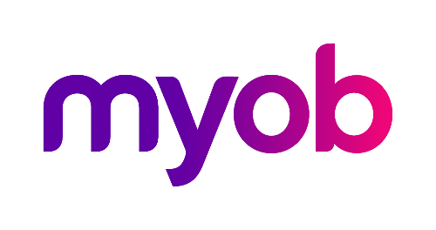
MYOB Greentree
Release Notes
2020.2.0

Contents
Introduction 1
Enhancements – Greentree Desktop 2
Fax Support Removed from Greentree Desktop 2
Workflow Published Financial Reports filter 3
Updated Gender Selection List on Maintenance Forms 3
Leave type display options 5
64 Bit Support for VBA Integration 5
Changing Your VBA Modules 5
Bug Fixes - Greentree Desktop 6
NZ Payroll 6
HR Leave Planning 6
CRM 6
eDocs 6
Job Cost 7
Purchase Orders 7
A&A rules - Sales Orders 7
Various Fixes 7

Introduction
Release 2020.2.0 consists of enhancements to both Greentree Desktop and Greentree Browser.
We’ve added 64-bit support to VBA integrations and modified the Gender selection options on maintenance forms. We’ve added a Workflow Financial Report filter, and new Leave type options to control whether accrued, entitled or both are shown on the Leave Panel in browser. Fax support has also been removed from Greentree Desktop.
In Greentree Browser, we’ve included enhancements to the display of leave and modified the Gender selection options on the Contact form.
This release also fixes bugs in Greentree Desktop and Greentree Browser.

Enhancements – Greentree Desktop
Release 2020.2.0 of Greentree Desktop includes:
- Removal of fax support
- Workflow Published Financial Reports filter
- Updated gender selection list on maintenance forms
- Leave type display options
- 64 bit support for VBA integration

Fax Support Removed from Greentree Desktop
We’ve removed the ability to generate faxes from Greentree Desktop. The changes you’ll see in the user interface include:
- The fax delivery method is no longer available for customer invoices, statements and receipts, supplier remittances, and purchase orders, and HR employee pay slips.
- The output methods Auto fax/email and Auto fax/email/print have been replaced by Auto email and Auto email/print.
- Note: We haven’t removed the Fax Address options on addresses, contacts, customers, organisations and suppliers. That option is also still available on import, export, maintenance, and reporting forms. We haven’t removed fax masks on Country Definition forms.
When you apply the package for Greentree 2020.2.0, Packman reports a clean-up performed by the deployment script which:
- Replaces the fax delivery method with the Print delivery method on customer, supplier, and employee records.
- Removes tasks that specify non-automatic fax output.
- Removed the FaxMan executables and libraries from the Greentree directory.
Check the report that Packman generates and take remedial action if needed.
We’ve also removed:
- These standard reports: Facsimile Transmission, Fax cover page, and Fax ‘In Error’ Listing.
- These Report Writer methods: Delete all fax infos, Get all fax infos, and Get all fax print jobs Report Writer.

Workflow Published Financial Reports filter
A filter has been added to the Workflow Published Financial Reports panel for ‘Include document library reports.’
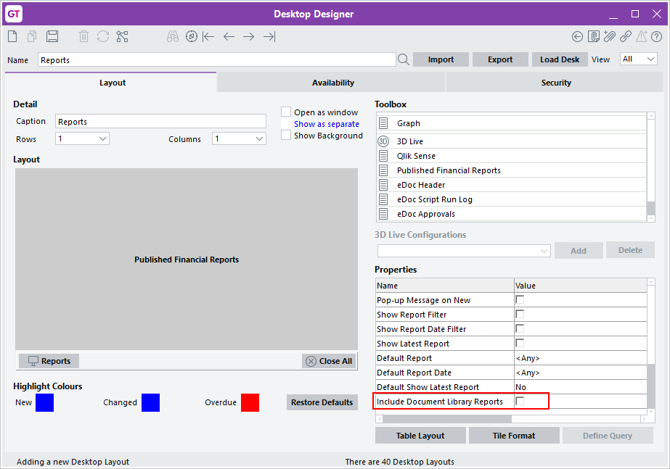
When selected, Published Financial reports and Library reports that the logged in user has security access to display on the Workflow desk panel. If not selected, only published financial reports display.

Updated Gender Selection List on Maintenance Forms
We’ve added the Other option to the Gender dropdown list on these forms:
- HR Employee Maintenance
- JC Employee Maintenance
- HR Applicant Maintenance
- Contact Maintenance
This enables you to select a gender for employees who identify as non-binary or who prefer not to specify their gender in their employee record.
Here’s the new option on the HR Employee Maintenance form:
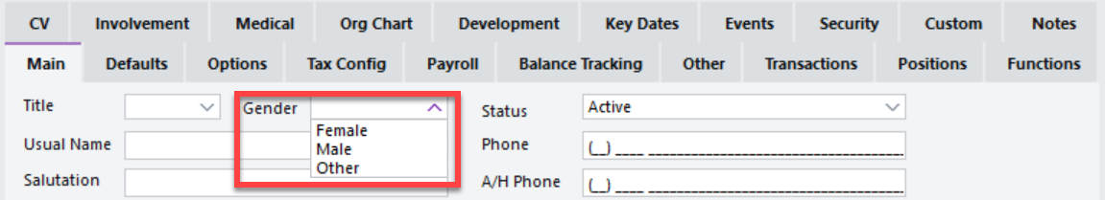

We’ve also added the Other option to the Gender dropdown list on the Contact form in Browser.
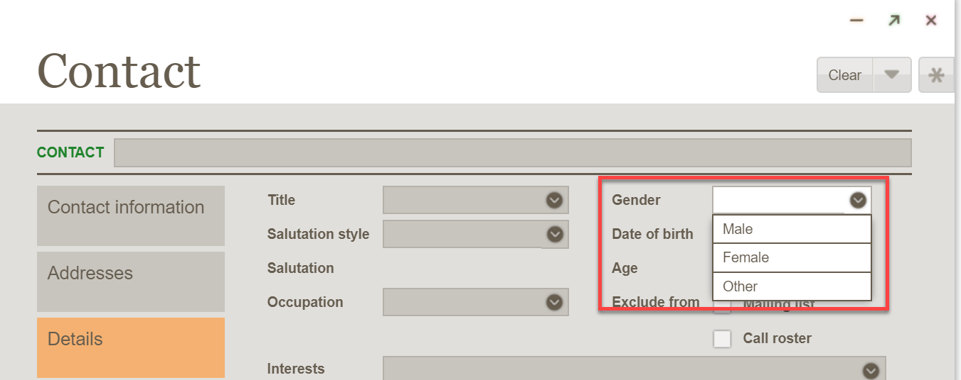

The FREE functions gtCRMContactInformation, gtHRApplicant, and gtHREmployee have also been updated to support the new gender option.
- This option does not apply to sites in the UK.

Leave type display options
Where a site is using Browser client AND a Transaction Type is selected as 'Available for Leave Planning” options have been added to the Transaction Type - Pay > Configuration tab to control which balances display on the Leave Balances panel

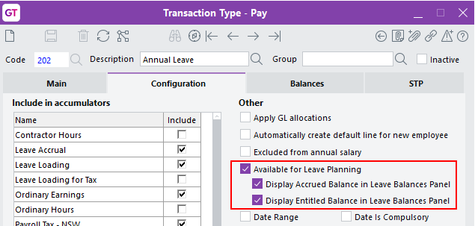
The options are “Display Accrued Balance in Leave Balances Panel” and “Display Entitled Balance in Leave Balances Panel”.

64 Bit Support for VBA Integration
VBA integration now works with the 64-bit Greentree Windows client.
If your site is running the Greentree Desktop 64-bit thin client and are already distributing the GreentreeInterface files in the \bin64 directory, you only need to make minor changes to your VBA modules (see below), if required.
If your site isn’t running the Greentree Desktop 64-bit thin client, you must deploy the existing GreentreeInterface.dll and exe files in the \bin64 directory to workstations that run the 64-bit version of Microsoft Office and register those files as administrator.

Changing Your VBA Modules
Previously generated VBA modules need a minor change to work with 64-bit applications. You can make that change in a text editor or using Office development tools.
Insert the word PtrSafe into these function declarations at the start of the .bas file:
Private Declare PtrSafe Function FindWindow…
Private Declare PtrSafe Function AllowSetForegroundWindow…

Bug Fixes - Greentree Desktop
We’ve fixed these issues in Greentree Desktop:

NZ Payroll
- Extra pay that you include in either the current pay or in a separate pay, but which has the same date as another pay, is now in the regular pay. Greentree Desktop now also correctly determines the tax on the extra pay.

HR Leave Planning
- Rules have been added to validate the start and finish date on the Leave Request Entry form to prevent Greentree Desktop from hanging if an invalid date is entered.

CRM
- When you import a communication that contains a link to a service request, the Service Request field on the Other tab of the Communication Maintenance form now updates with the number of the linked service request.
- The location for inventory lines in job quotes now uses the inventory item’s primary location and not the location set on the PO User Preferences form.
- When creating a JC Estimate from a Sales Quote, the inventory location is updated.
- Error 14079 no longer occurs when open filed inbound email that contains a filed by username of more than 30 characters.

eDocs
We’ve fixed these issues in eDocs:
- When using Advanced Invoicing, the status on a PO shipment updates with the correct status when you generate an invoice using the AP Invoices feature.
- The IN Transaction Analysis Code field is no longer blank when you open an AP invoice that was imported with the IN Transaction Analysis option.

Job Cost
- If you reopen a job and then close it in a different period, Greentree Desktop does not duplicate GL revenue recognition postings.
- Revenue recognition general ledger postings no longer display a blank sub code when you view the batch edit list or general ledger enquiry. The job number now displays as the sub code.
- On save of a JC Credit note, the job field is set to read only to be consistent with JC AR Invoice.
- Greentree Desktop retains changes that you make to the Job field on an AR invoice. The field longer reverts to its previous value when you save the invoice.

Purchase Orders
- You can no longer save purchase order receipts that have an incorrect foreign exchange rate.
- The error ‘Additional charge: Duty value in the shipment line item incorrect’ no longer occurs if a user zeros out an Import Duty line on a PO Shipment, modifies another line, then saves and reloads the PO Shipment.

A&A rules - Sales Orders
- Rules on a sales order now trigger an instant alert and send an email in both Greentree Desktop and Greentree Browser.

Various Fixes
- You can no longer update finalised or inactive jobs using the FREE gtINJCLine function.
- In Windows Designer, information that you enter or modify in a custom UDF and/or tree field that moves to the Job Card tab is now saved.
- We’ve corrected spelling errors in the descriptions of Adjust total costs and Inventory system scripts.

